

INFORMATICS INSTITUTE OF TECHNOLOGY

In Collaboration with UNIVERSITY OF WESTMINSTER

**6MARK027C  
Digital Marketing, Social Medial and Web Analytics**

**Coursework 1**

Name: Muhammad Areeb Niyas

20200129 | w1809939

Word Count - 2761  
References - 46

Module Leader: Mr Prassanna Pathmanathan

Submitted in partial fulfilment of the requirements for the BSc(Hons) in Computer Science degree at the University of Westminster.

**Date: March 2024**

Table of Contents

Table of Figures ii

QUESTION 1: DIGITAL MARKETING MODELS 1

1.1 Selected Online Company 1

1.2 Digital Marketing Funnel 1

1.3 Diagram 2

1.4 Stages 3

1.5 Case Study 4

1.6 Technical Terms 14

QUESTION 2: SEARCH ENGINE OPTIMIZATION 15

2.1 Site URL 15

2.2 Screenshots of Pages Created 16

2.3 Form to Collect Email Addresses 22

2.4 Keyword Analysis 23

2.5 Webpage Content Optimization 26

2.6 Backlinks and Internal Linking 31

2.7 PageRank Algorithm 37

2.7.1 Diagram 37

2.7.2 Rationale and Intuition of PageRank Algorithm 39

2.7.3 PageRank Algorithm Manipulation and Potential Countermeasures 39

QUESTION 3: Social Media and Traditional Marketing Methods 41

3.1 Social Signals Definition 41

3.2 Social Signals and Search Engine Algorithms 44

3.2.1 Advantages 45

3.2.2 Limitations 45

3.3 Recent Trends in Search Engine Market and Consumer Search 45

3.4 Social Media Marketing and Long-term Relationships 46

3.4.1 Consumer and Producer 46

3.4.2 Long-term Consumer-Producer Relationship 46

3.3.3 Methods to Strengthen Long-term Consumer-Producer Relationships 46

3.3.4 Real-world Example 48

References I

# Table of Figures

Figure 1: Ash's Funnel Diagram (self-composed) 2

Figure 2: Auto Pal Facebook Page 4

Figure 3: Auto Pal TikTok Page 5

Figure 4: Auto Pal Instagram Page 5

Figure 5: Using hashtags to reach wider audience 6

Figure 6: Instagram paid advertising analytics 6

Figure 7: Landing page of Auto Pal website 7

Figure 8: Appointment Booking Page 8

Figure 9: Appointment Confirmation Page 8

Figure 10: Product Page 9

Figure 11: Payment Options 9

Figure 12: Discounted Products 10

Figure 13: Special Offers 11

Figure 14: Auto Pal Seasonal Sales 11

Figure 15: Free Customized Video 12

Figure 16: WhatsApp Community for Customers 13

Figure 17: Personalized Emails. 13

Figure 18: Follow up emails 14

Figure 19: Homepage (Page 1) 16

Figure 20: About (Page 2) 17

Figure 21: Music (Page 3) 18

Figure 22: Awards (Page 4) 19

Figure 23: Contact (Page 5) 20

Figure 24: Sitemap 21

Figure 25: Form to collect emails 22

Figure 26: Analysis on existing content 23

Figure 27: Identifying competition using google keyword planner 24

Figure 28: Evaluating words using Wordstream 25

Figure 29: Keyword Tree 26

Figure 30: Before optimization: homepage 27

Figure 31: Before optimization: about page 28

Figure 32: After optimization: homepage 29

Figure 33: After optimization: about page 30

Figure 34: Summary: linking (self-composed) 31

Figure 35: Internal Linking: About page 33

Figure 36: Internal Linking: Home 34

Figure 37: Backlink from Santhush Weeraman 35

Figure 38: Backlink from Sahan Ranwala 35

Figure 39: Backlink from Bathiya Jayakody 36

Figure 40: Backlink from Facebook 36

Figure 41: Annotated PageRank algorithm diagram 38

Figure 42: High reach: Instagram post analytics 41

Figure 43: Low reach: Instagram post analytics 42

Figure 44: Quality content: Dialog 43

Figure 45: Trivia question by Dialog 43

Figure 46: Active responses from Dialog 44

Figure 47: Personalized messaging: Auto Pal 48

# QUESTION 1: DIGITAL MARKETING MODELS

## 1.1 Selected Online Company

AutoPal

## 1.2 Digital Marketing Funnel

A digital marketing funnel refers to the entire process or journey where suspects become actual customers for a company (Digital Marketing Funnel Stages, 2023). The different techniques used in this journey can be represented in a funnel. The following section illustrates the Ash’s funnel to get a deeper understanding.

1.3 Diagram  
Following diagram illustrates the steps in a digital marketing funnel (Ash’s funnel process).

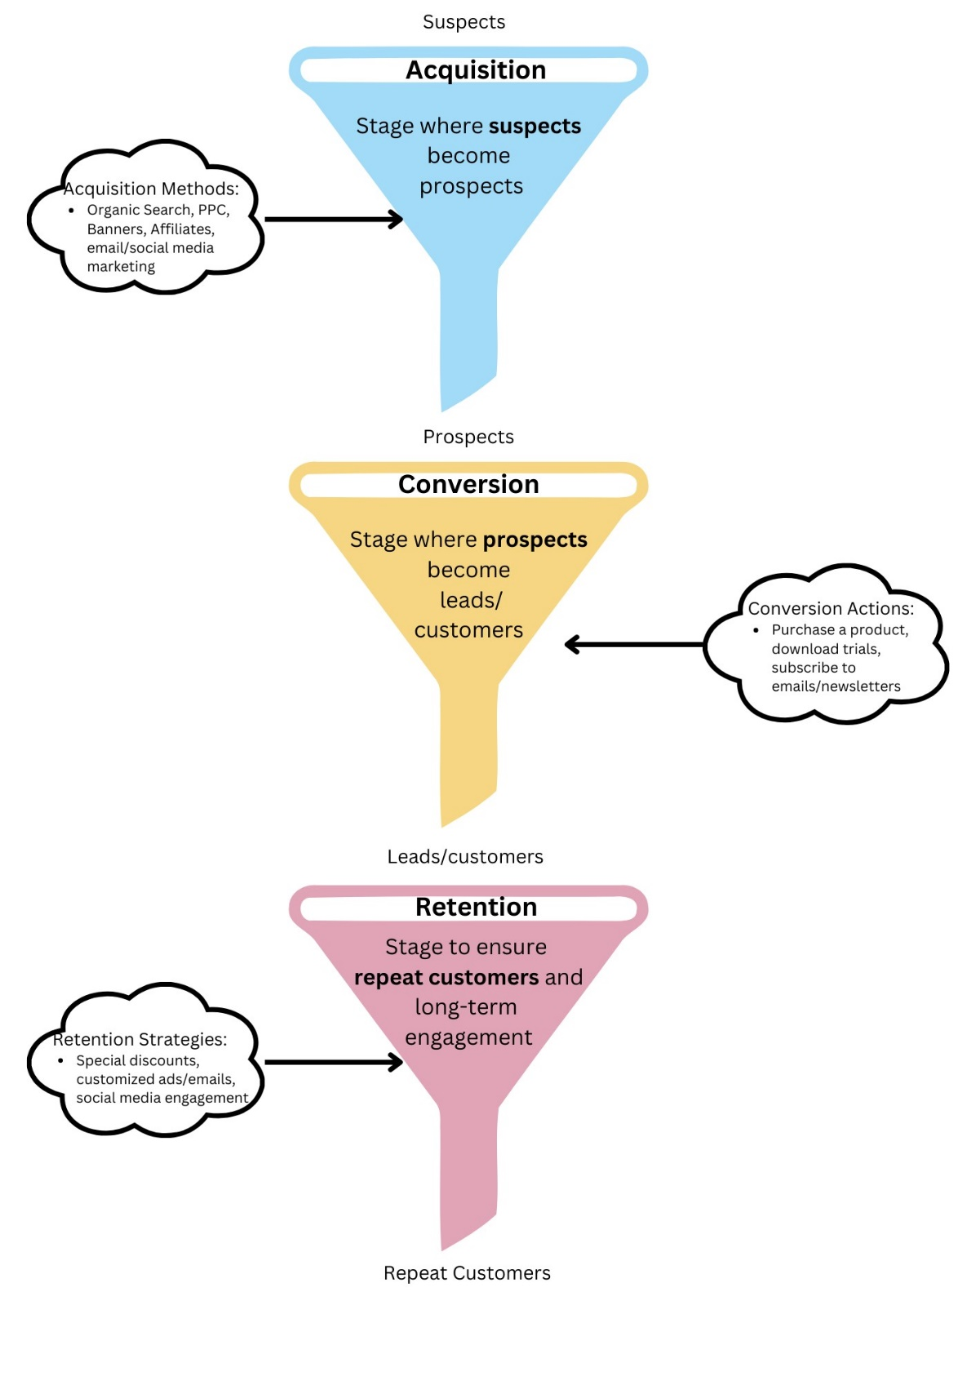

Figure 1: Ash's Funnel Diagram (self-composed)

## 1.4 Stages

**Suspects** are individuals that have no prior relationship with a company or product. These are the individuals that need to be encouraged to visit a website or become a potential buyer (Meissner, 2020).

**Acquisition**

Process of introducing and creating awareness of a business or product using blogs, social media platforms, email/search/content marketing, referrals and similar methods (Indeed, 2023). It is important because waiting for customers to come to you won’t assure sales or profits. Therefore, it is a strategical way of attracting customers to your business for the longer run (Decker, 2022). This is the stage where suspects become **prospects.**

**Conversion**

Prospects are individuals that are aware or have shown interest in your business/product (Bruin, 2017). This stage focusses on persuading and motivating prospects to take an action such as clicking a button or completing a form (Meissner, 2020). The objective being to increase the **conversion rate**, which is the percentage of users who complete a desired action (Chappal, 2023). This would convert them into **leads or customers**.

Lead generation takes people who have shown interest and turns them into qualified leads**. Leads** are people who have the prerequisites to become your customer (Spilka, 2023) and when you complete a purchase, you become a **customer**.

**Retention**

In order to maintain success after conversion, the retention process will help to keep your customers and leads (Retention Funnel: What, When, How and Why, 2023). This is important because repeat customers are vital for a business. It is cheaper than getting new customers and they are more likely to recommend your business due to loyalty. Some ways of retention strategies include: personalized ads, follow up emails, good customer service and loyalty programs (Shepherd, 2019). This way a business can sustain and deepen customer relationships.

## 1.5 Case Study

Auto Pal is a well community-known company in Sri Lanka for all your car needs such as accessories, parts and modifications.

**Acquisition**

In order to reach and acquire prospective customers, Auto Pal uses a wide range of techniques including social media marketing, SEO, email marketing and PPC. They also use traditional marketing methods such as billboard advertising and sponsorships.

Firstly, they have an impressive social media presence with 30,000+ followers on Facebook, 18,000+ followers on TikTok and ~2000 followers on Instagram.

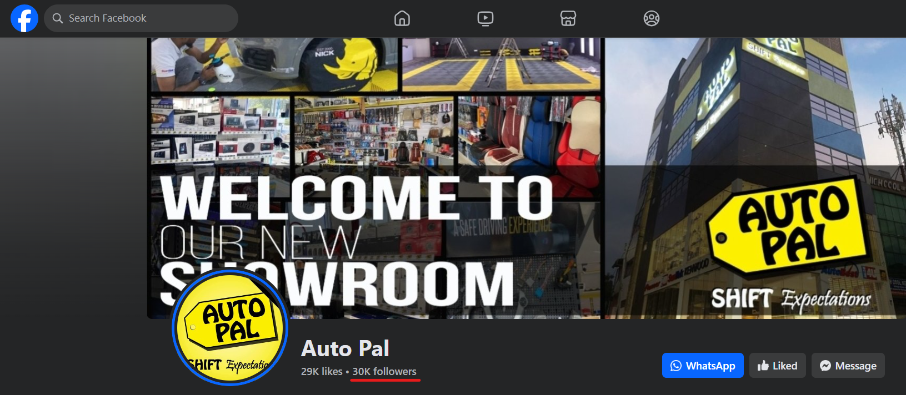

Figure 2: Auto Pal Facebook Page

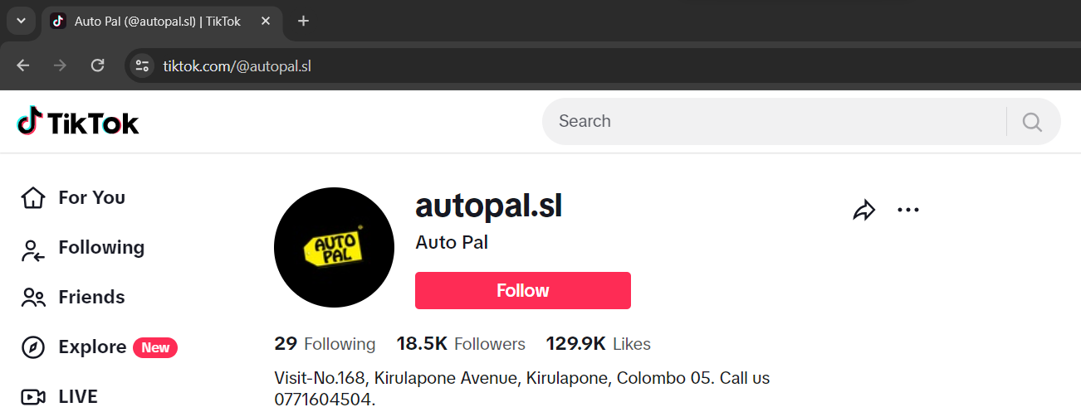

Figure 3: Auto Pal TikTok Page

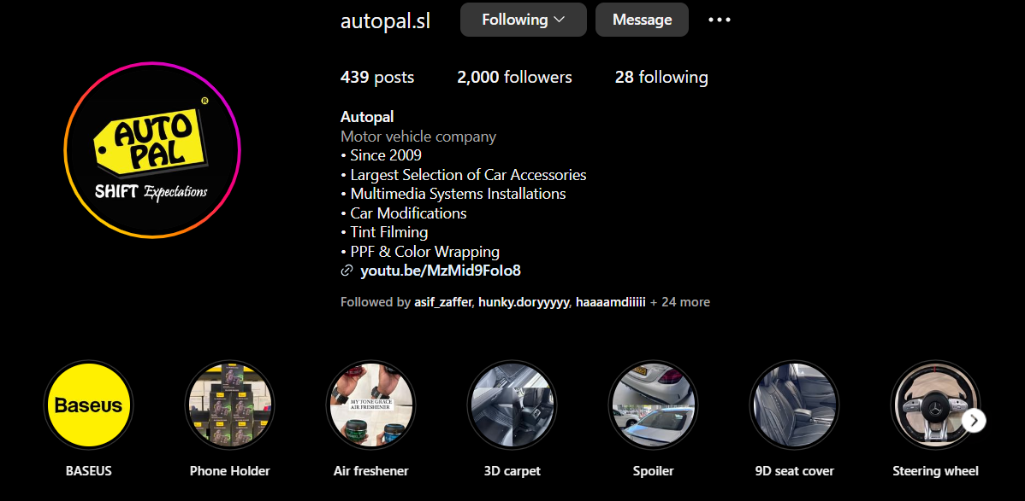

Figure 4: Auto Pal Instagram Page

By having a significant social media presence and posting regular **updates every day**, they manage to reach around 1000+ per post.

Using hashtag marketing by researching keywords related to your content will boost involvement and make your content easier to find (Wolanin, 2023). Auto Pal uses hashtags so that potential customers who are searching via hashtags will find Auto Pal’s content due to relevancy.

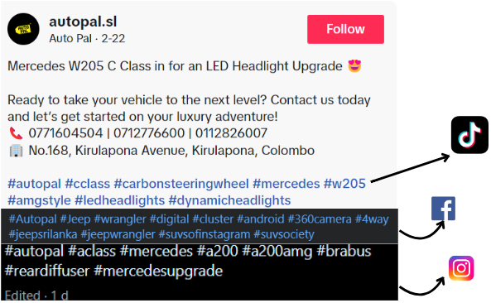

Figure 5: Using hashtags to reach wider audience

They also use the method PPC in Instagram by boosting their posts and reels which helps reach over 7000+ people and drive traffic into their website and Instagram direct messages.

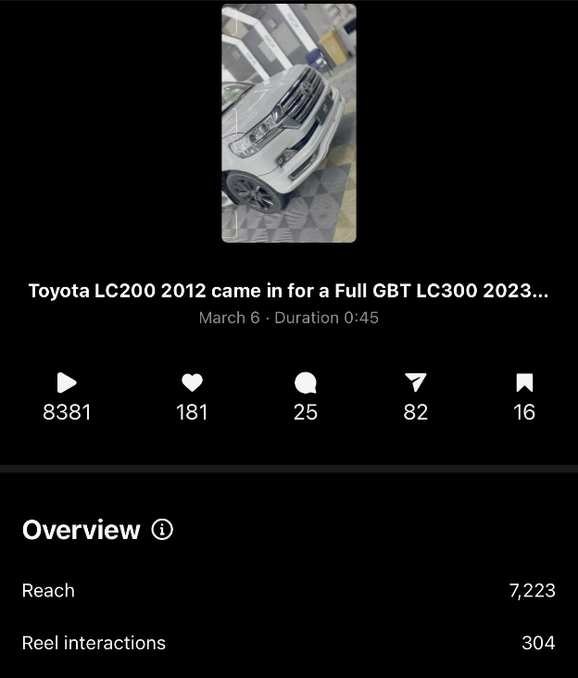

Figure 6: Instagram paid advertising analytics

Auto Pal also has an eye-appealing website which provides a good first impression with their landing page.

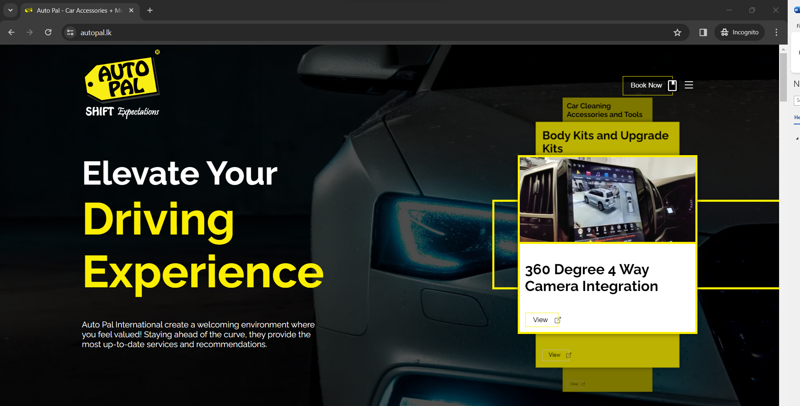

Figure 7: Landing page of Auto Pal website

**Conversion**

To turn prospects into customers, Auto Pal has used offers, discounts and a centralized appointment booking page in their website along with selling products.

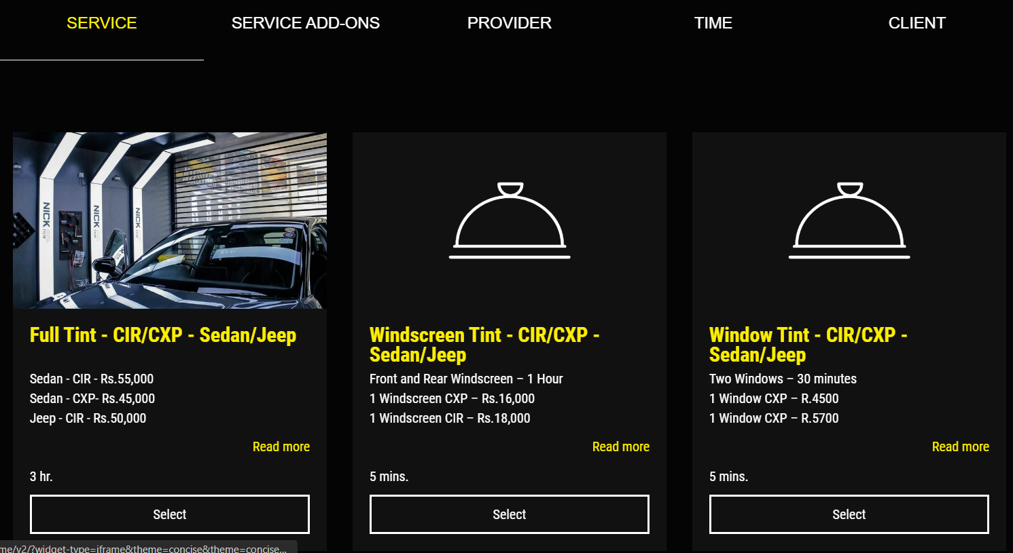

Figure 8: Appointment Booking Page

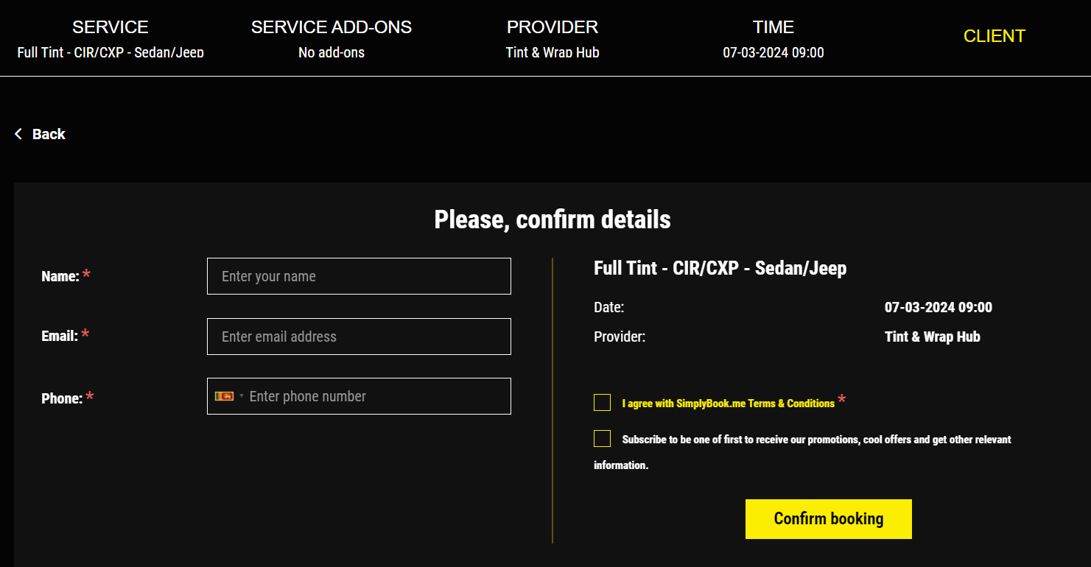

Figure 9: Appointment Confirmation Page

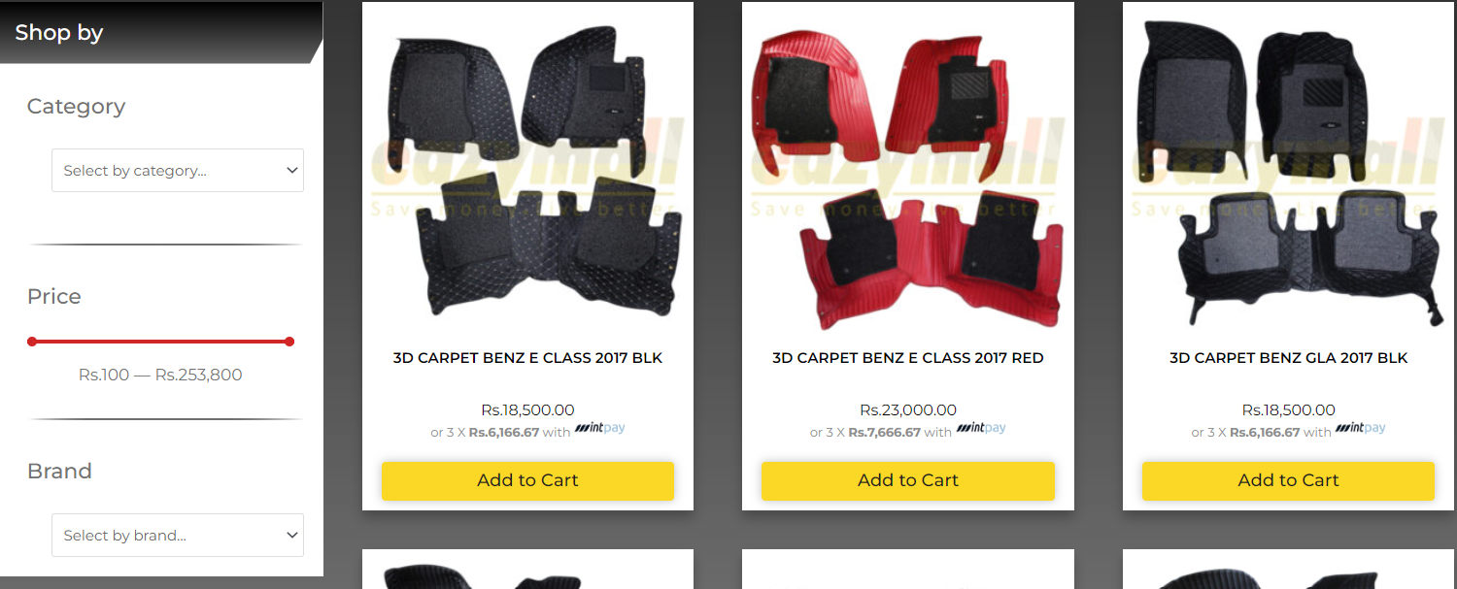

Figure 10: Product Page

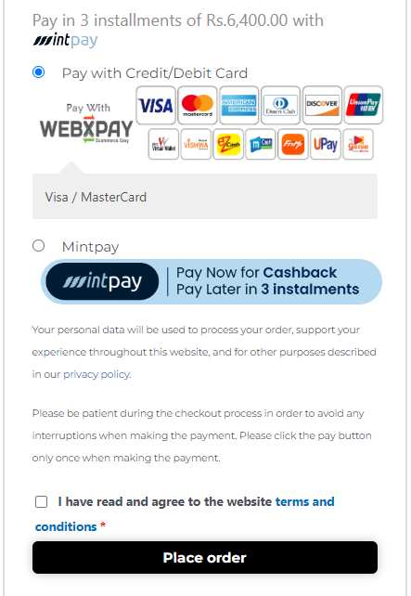

Figure 11: Payment Options

Including a **platform** to book appointments for modifications and see the services available along with a selling page for **multiple products** with multiple **payment** **options** including **installments** increases the **convenience** for the user and help **increase** the **conversion rate**.

They also host seasonal sales and clearance sales to generate more leads and increase the conversion rate.



Figure 12: Discounted Products

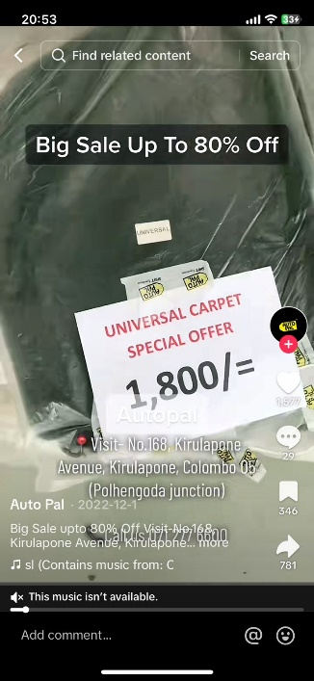

Figure 13: Special Offers

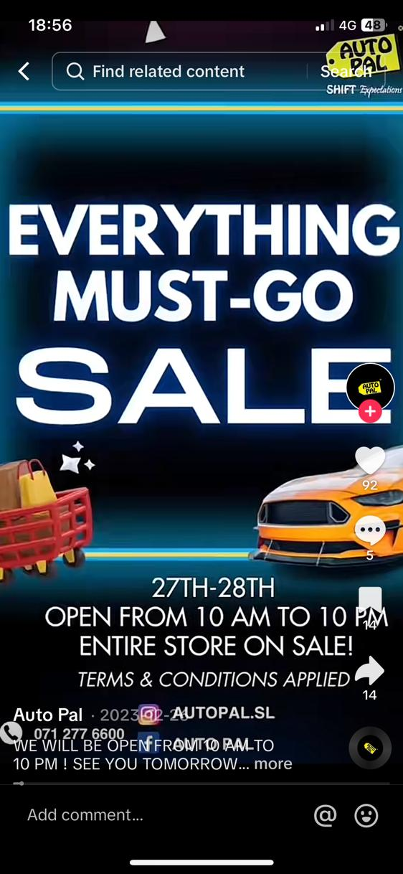

Figure 14: Auto Pal Seasonal Sales

Using these conversion strategies Auto Pal turns prospects into leads or customers efficiently and successfully.

**Retention**

Auto Pal uses multiple techniques to get repeat customers and maintain relationships. One such way is by offering **free custom videos** to customers after modifications to their car.

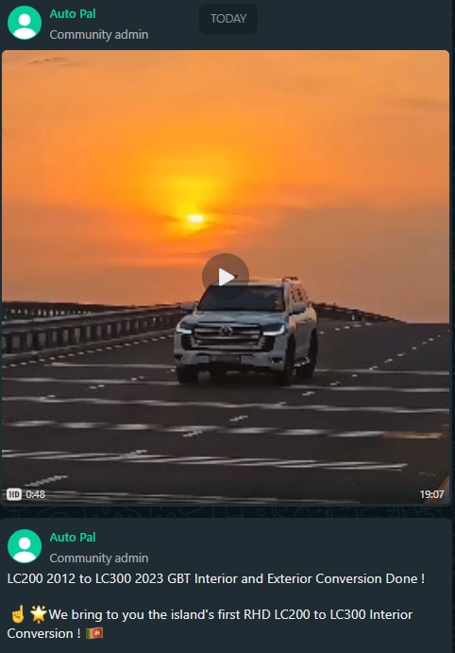

Figure 15: Free Customized Video

Also, Auto Pal hosts a WhatsApp community where **the latest updates, discounts, offers are released regularly**. Only customers and stakeholders are added to this group.

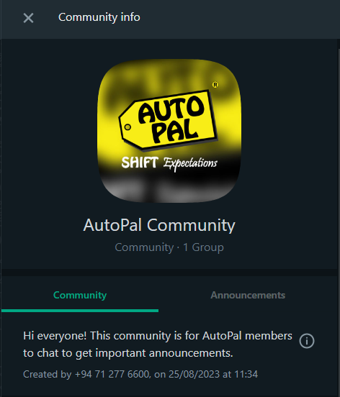

Figure 16: WhatsApp Community for Customers

Auto Pal also sends out personal emails to collect feedback which makes the customer feel important and helps retain them.

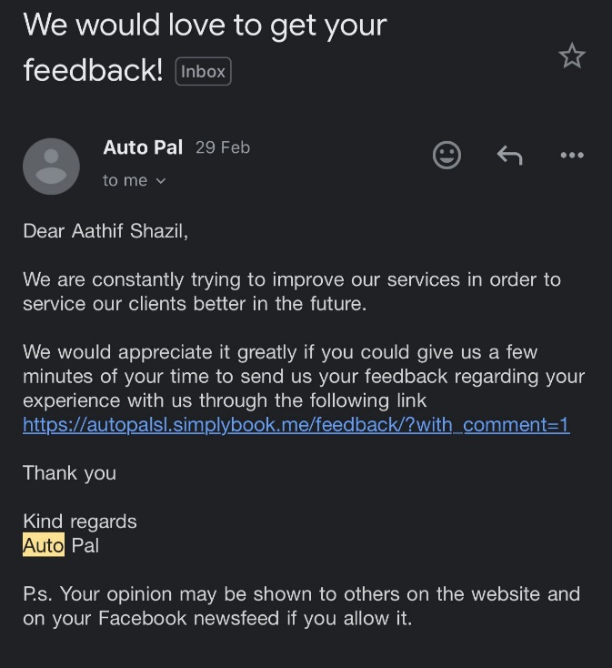

Figure 17: Personalized Emails.

Finally, Auto Pal sends follow-up emails to customers which makes it very convenient for customers.

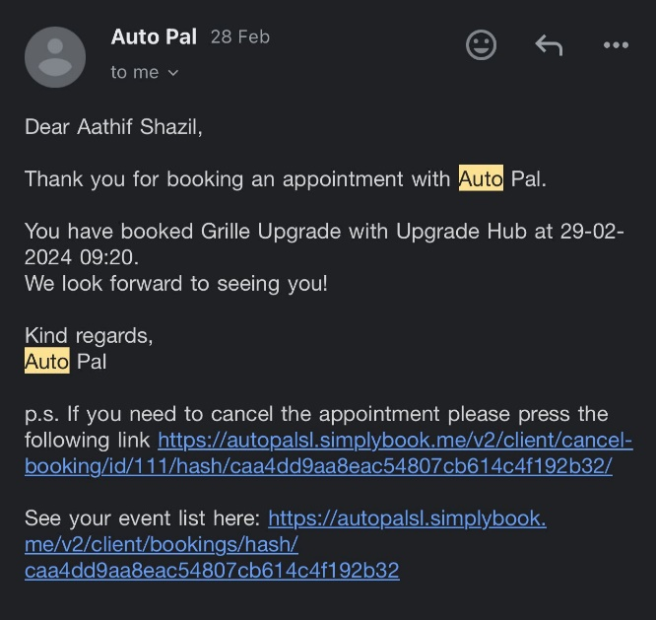

Figure 18: Follow up emails

## 1.6 Technical Terms

* PPC – Pay per click offers advertisers to target a specific set of people and each time a user clicks on their ad, a fee is cut.
* Email Marketing – This involves sending emails to a group of people promoting a product or service.
* Content Marketing – A long term strategy using different types of content shared such as posts, pictures, blogs, videos etc. This engages suspects, prospects and customers.
* Stakeholders – Individuals or groups of people who have shown interest in the business or service/products offered.

# QUESTION 2: SEARCH ENGINE OPTIMIZATION

## 2.1 Site URL

<https://sites.google.com/iit.ac.lk/umaria/>

## 2.2 Screenshots of Pages Created

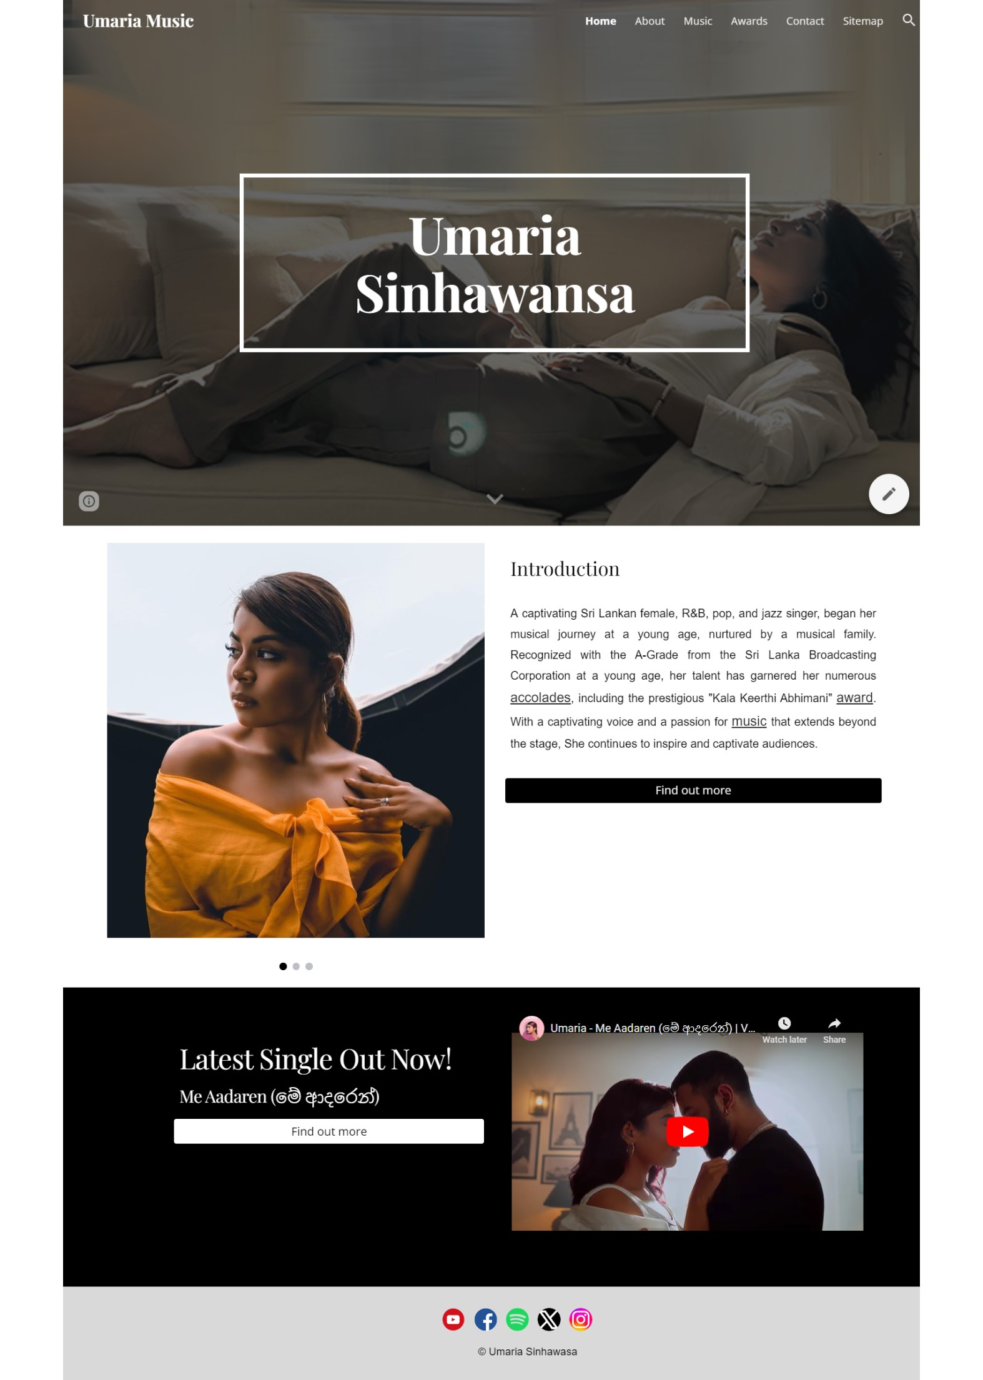

Figure 19: Homepage (Page 1)

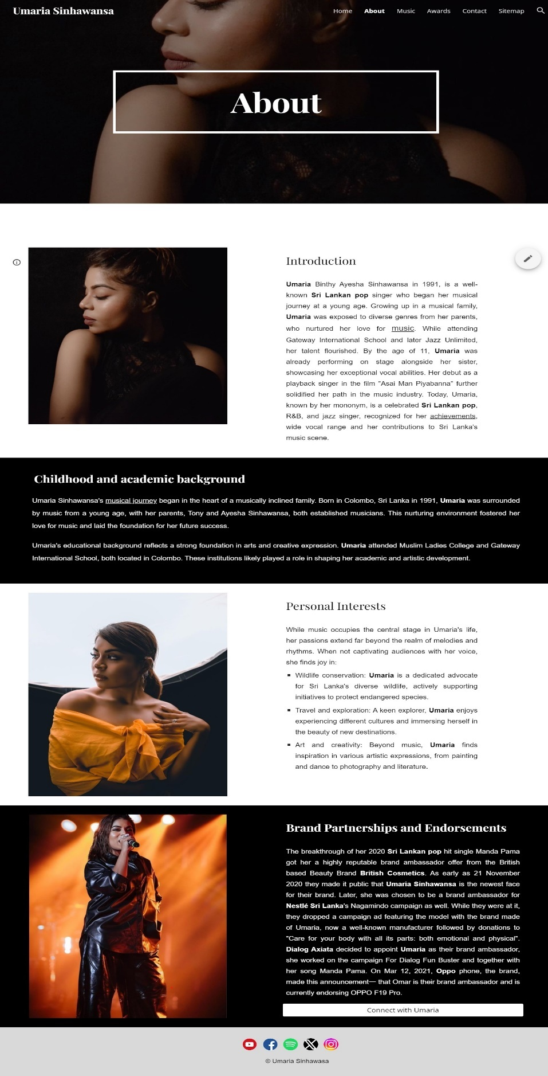

Figure 20: About (Page 2)

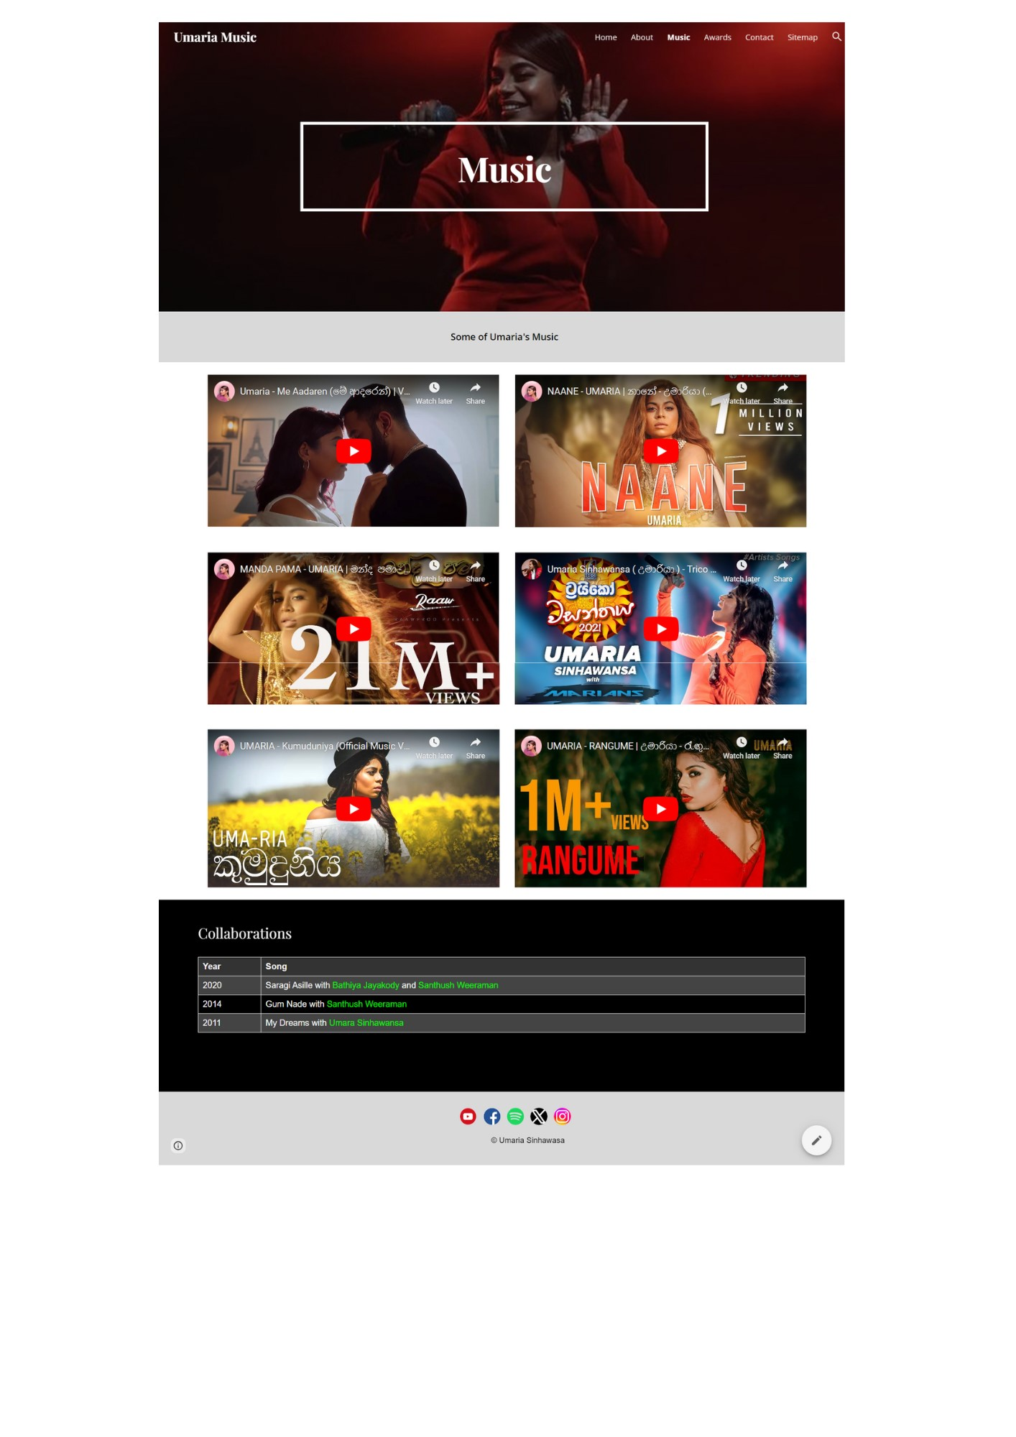

Figure 21: Music (Page 3)

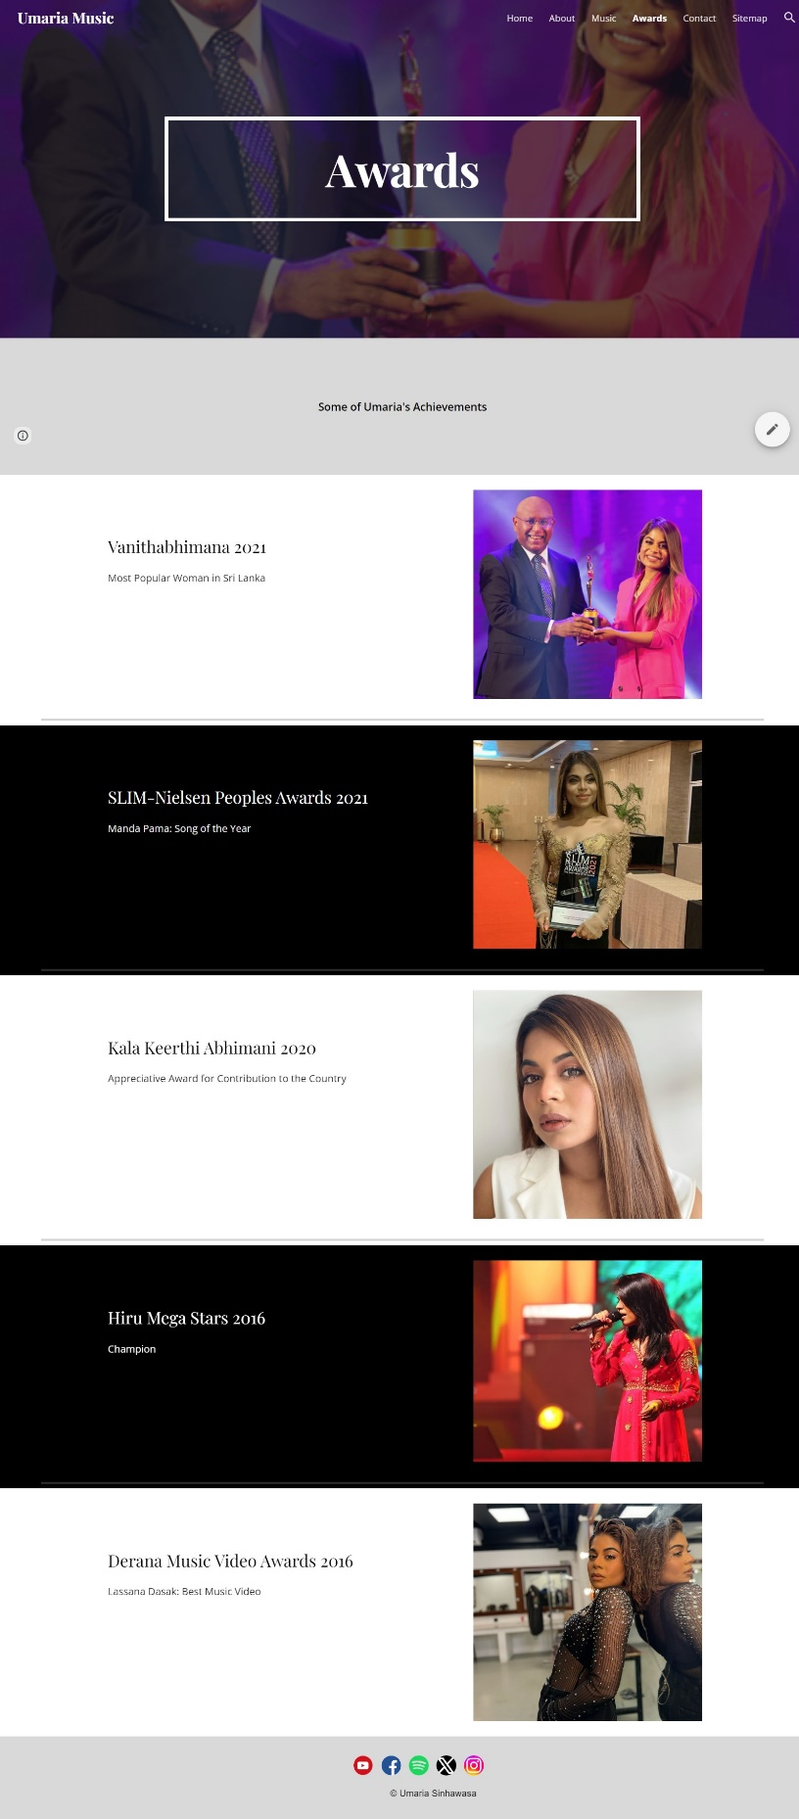

Figure 22: Awards (Page 4)

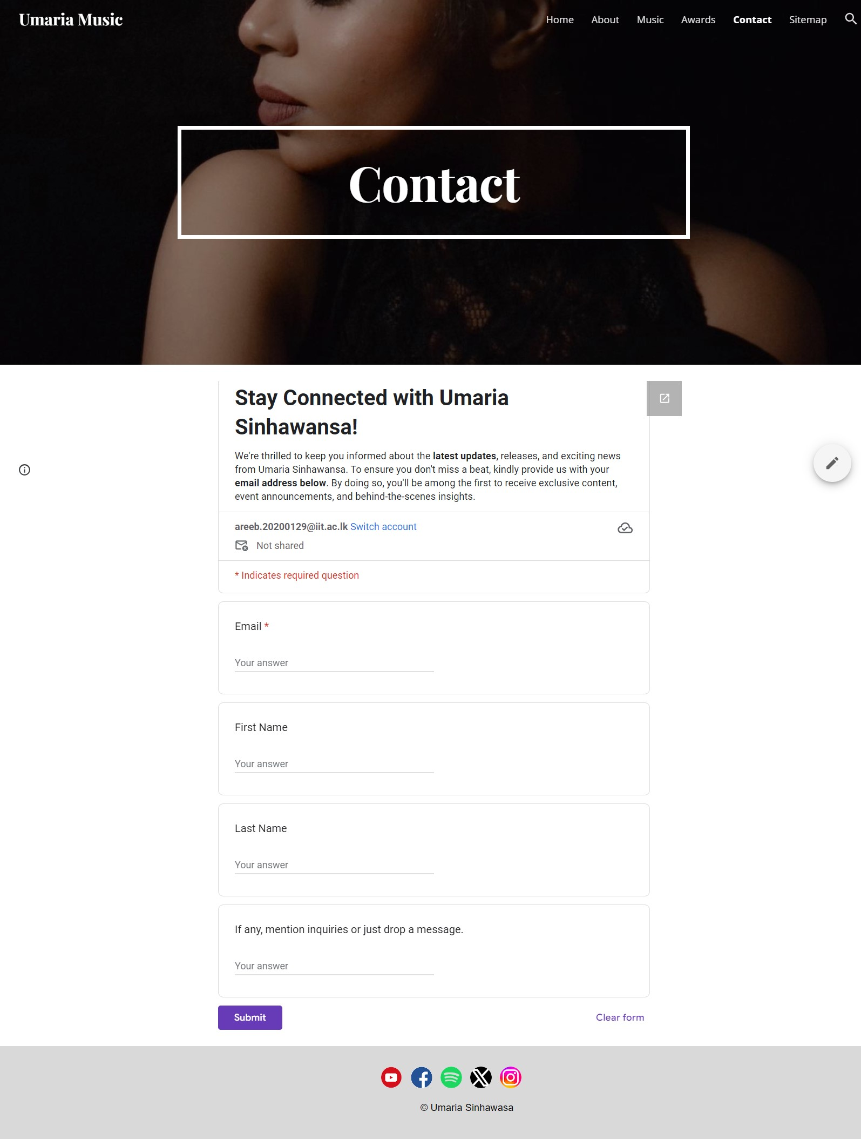

Figure 23: Contact (Page 5)

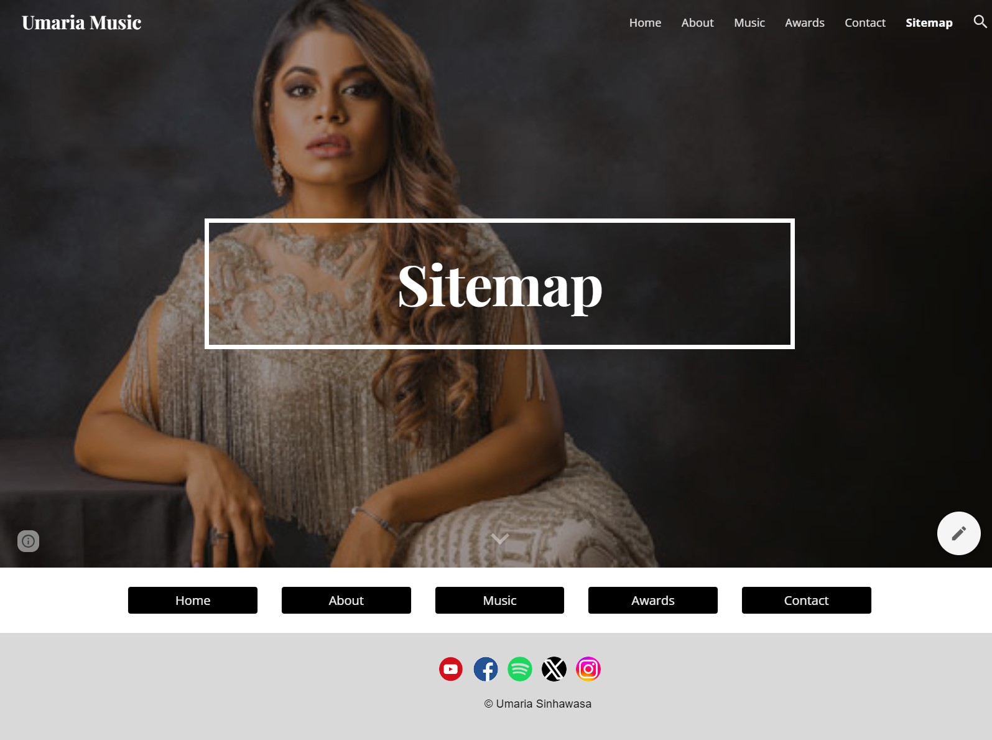

Figure 24: Sitemap

## 2.3 Form to Collect Email Addresses

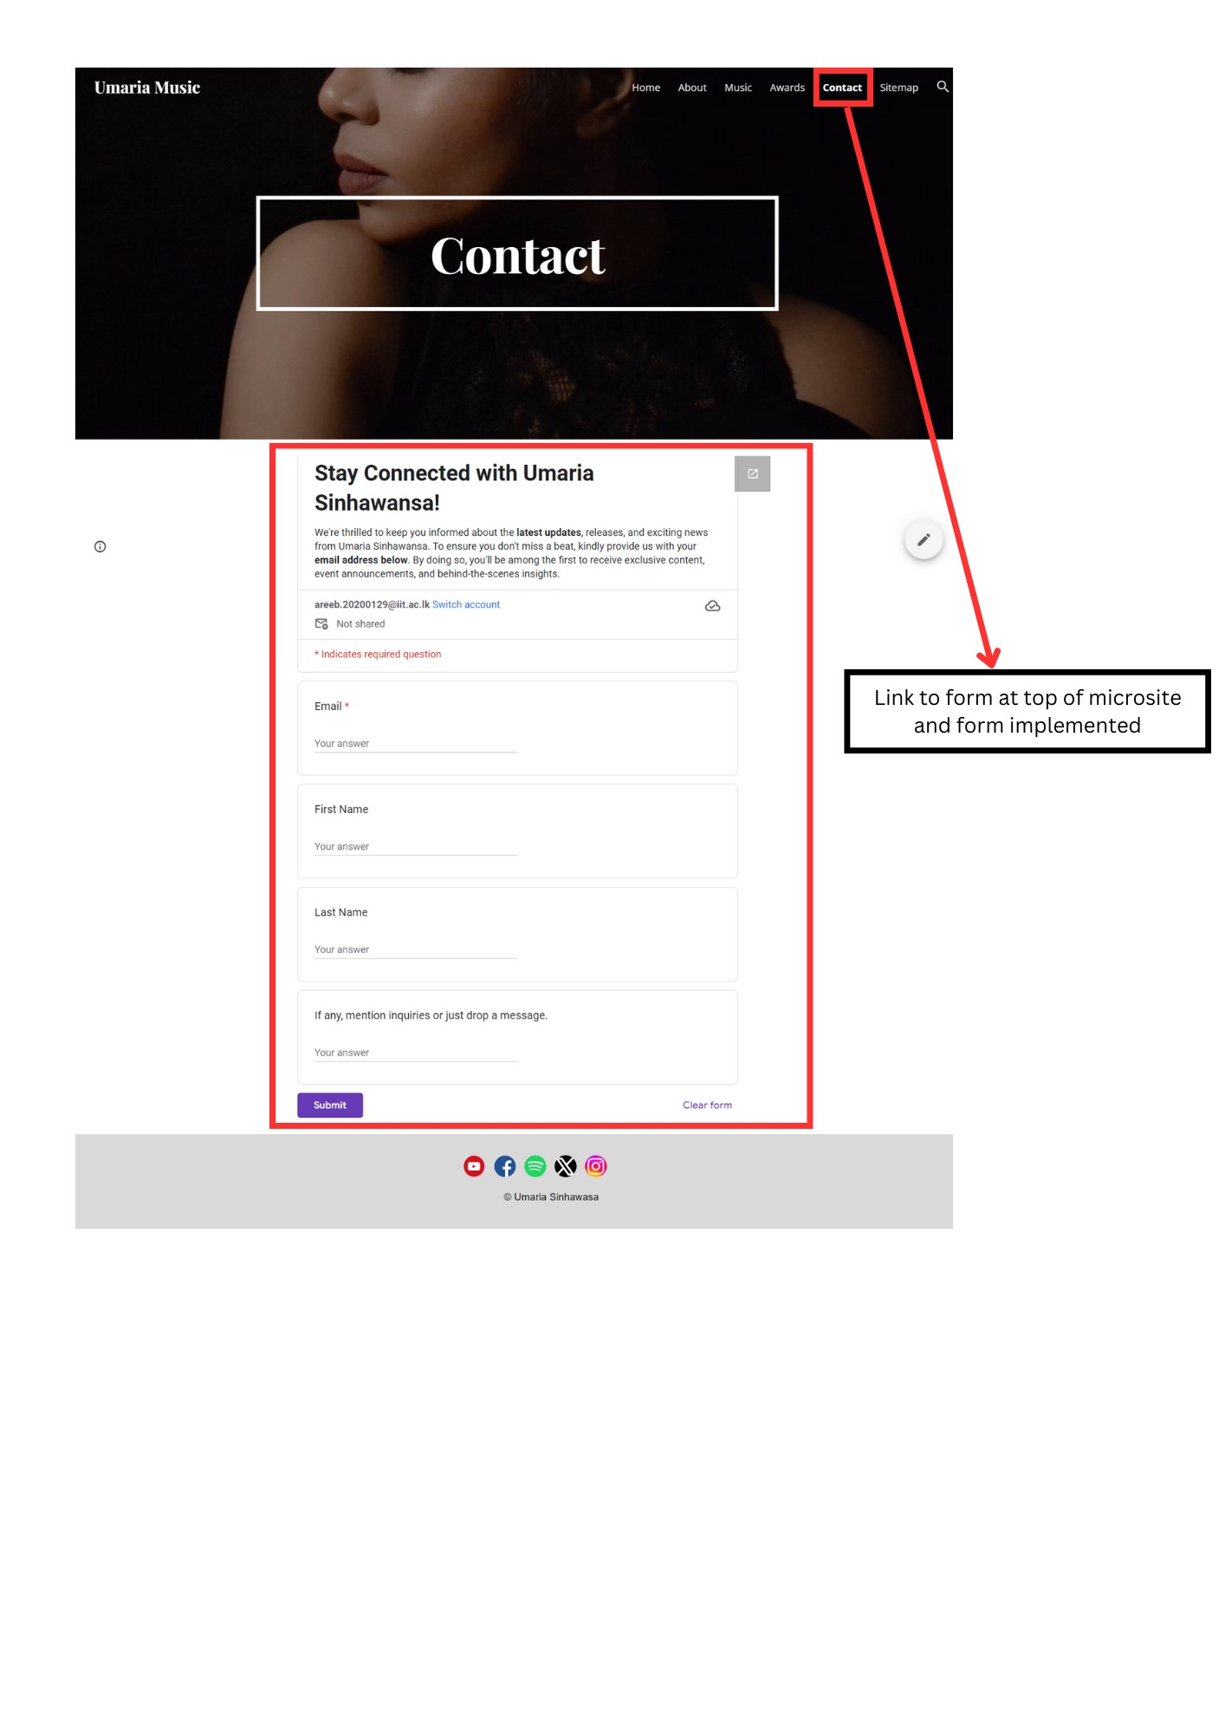

Figure 25: Form to collect emails

[Raw Google Form Link](https://forms.gle/dvVgjox4UbRmgRDEA)

## 2.4 Keyword Analysis

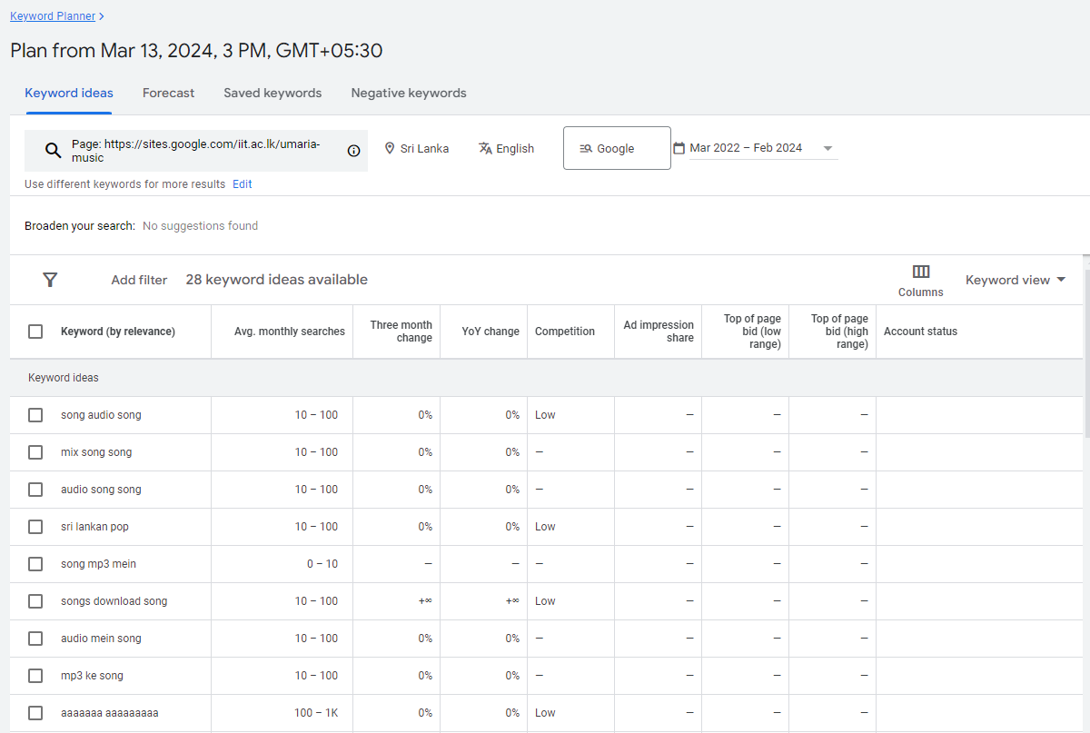

Figure 26: Analysis on existing content

Identified sets of seed phrases: sri lankan pop, female artists, female singers, umaria, umaria sinhawansa, the voice sri lanka.

A keyword is a word or set of words that is used to search a particular topic. **Keyword semantics** involve understanding the context and meaning behind specific words and their queries. **Modifiers** like ‘online’, ‘best’ and ‘cheap’ can impact the type of search as it adds specificity while **variations** provide similar or alternative forms related to the keyword or topic.

**Search Volume and Keyword Competitiveness**

The search volume refers to how many people are querying a particular keyword for a given period of time (Silva, 2023). If the keyword is popular and has a lot of queries, then it is considered competitive. Higher the competition, harder it will be for the keyword to have an effect and rank (The Ultimate Guide to Keyword Competition, 2023).

To analyse the search volume and competition for Umaria Sinhawansa, further analysis was conducted on the seed phrases.

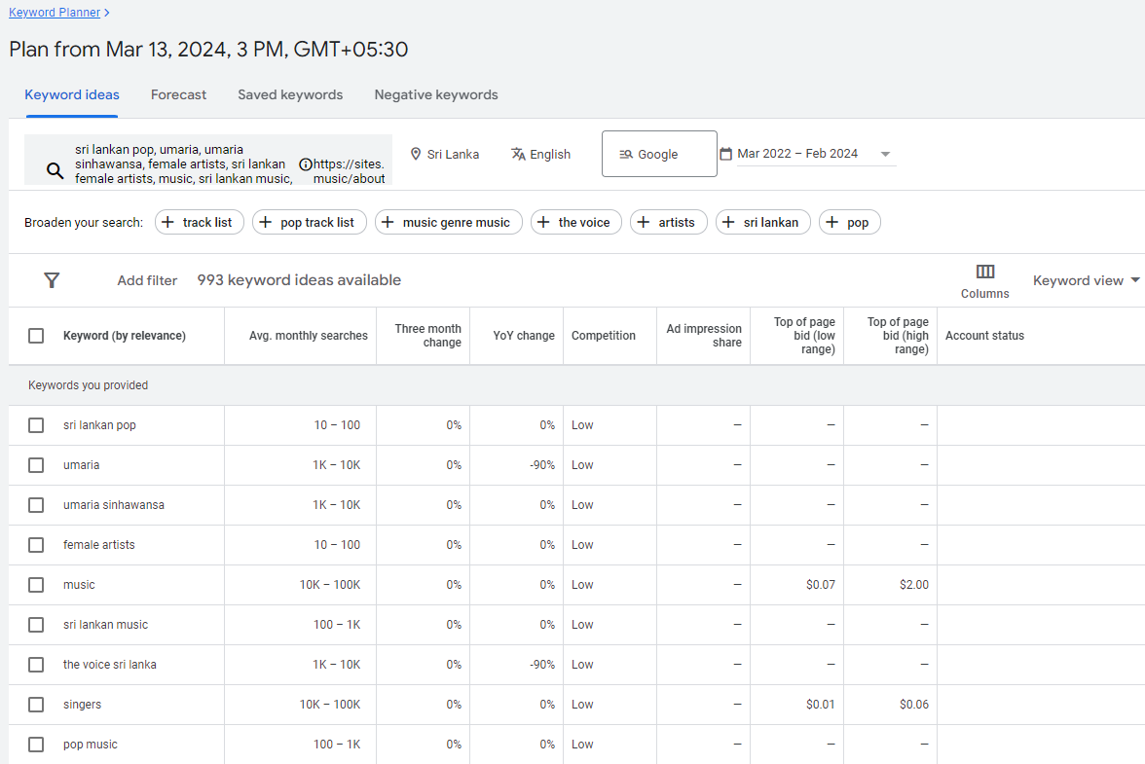

Figure 27: Identifying competition using google keyword planner

According to relevance of the content, keywords such as umaria, umaria sinhawansa and pop music seem ideal so it was analyzed even further.

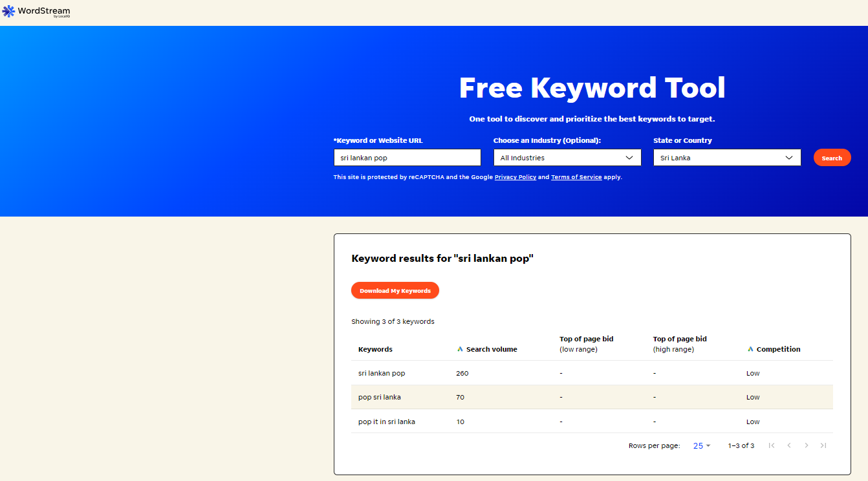

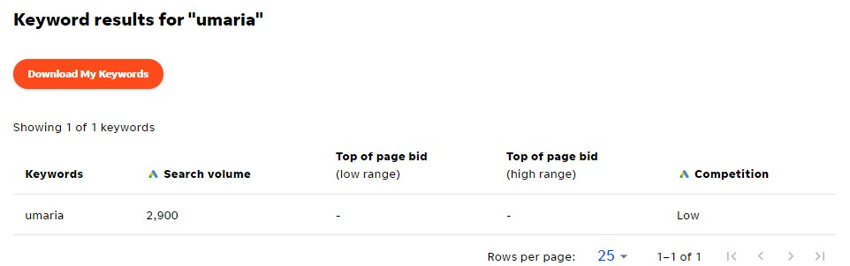

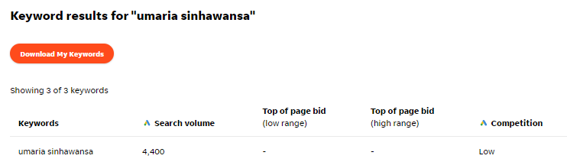

Figure 28: Evaluating words using Wordstream

So it was identified to use keywords due to less competition and decent search volumes: sri lankan pop, umaria and umaria sinhawansa to optimize content.

**Keyword Tree**

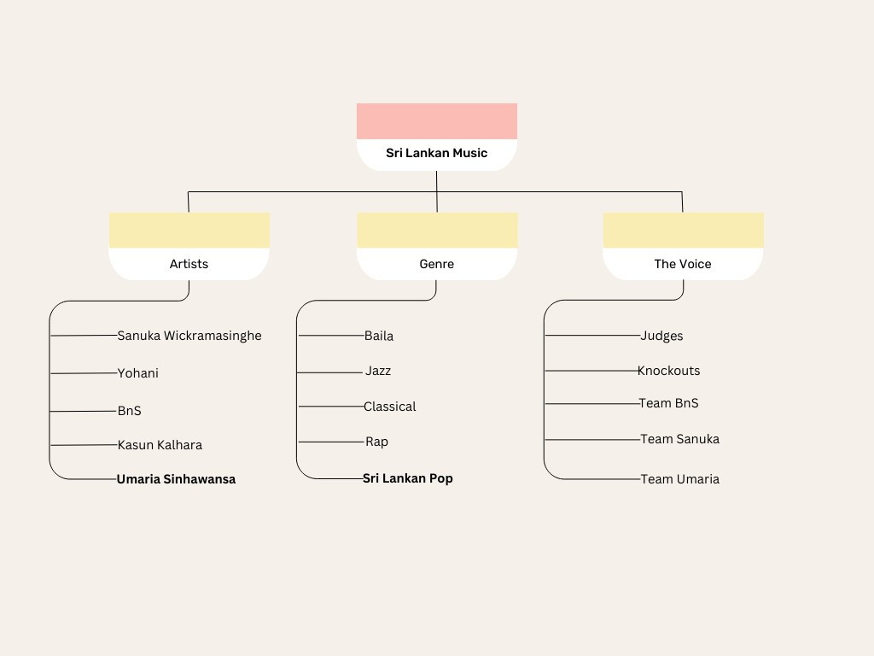

Figure 29: Keyword Tree

## 2.5 Webpage Content Optimization

The homepage and about page were optimized with the identified keywords mentioned previously. The keywords were incorporated into the title and navigation bar in the homepage along with the introduction where words such as she or her were replaced with Umaria or Umaria Sinhawansa. While the about page also highlighted more instances and enhanced the visibility for users searching for "Umaria," "Umaria Sinhawansa," and "Sri Lankan pop". The keyword was also incorporated into the URL as umaria music did not have any searches according to previous evaluation.

Site link before optimization – <https://sites.google.com/iit.ac.lk/umaria-music/>

Site link after optimization - <https://sites.google.com/iit.ac.lk/umaria/>

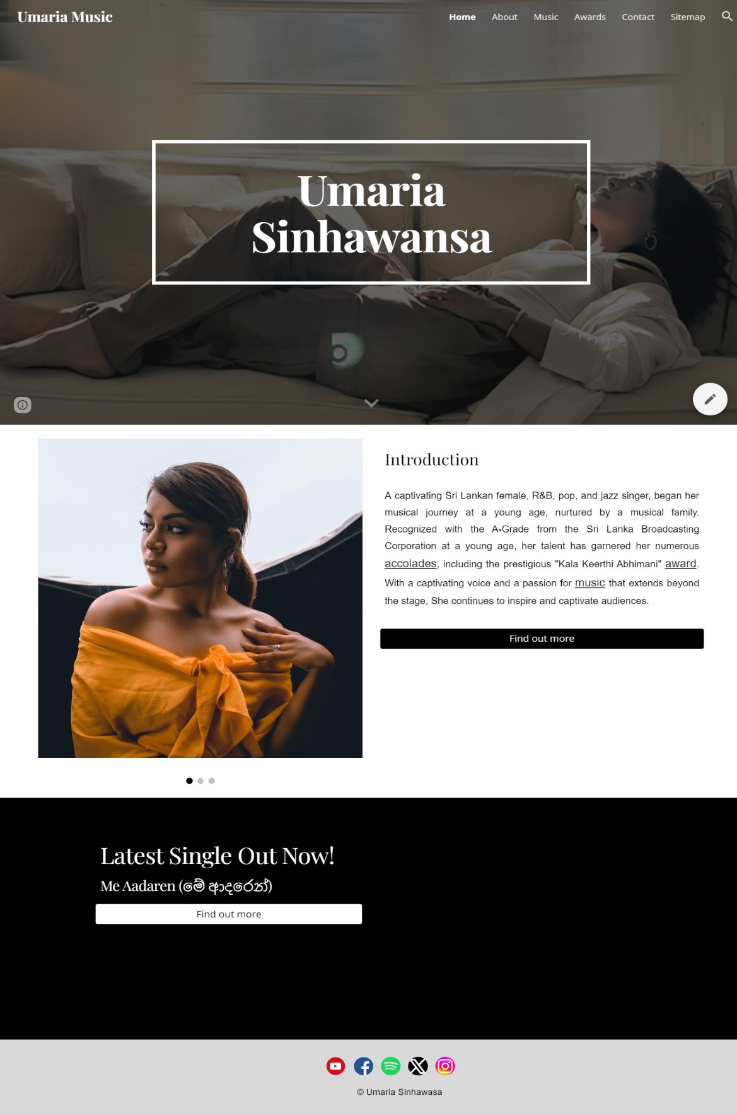

Figure 30: Before optimization: homepage

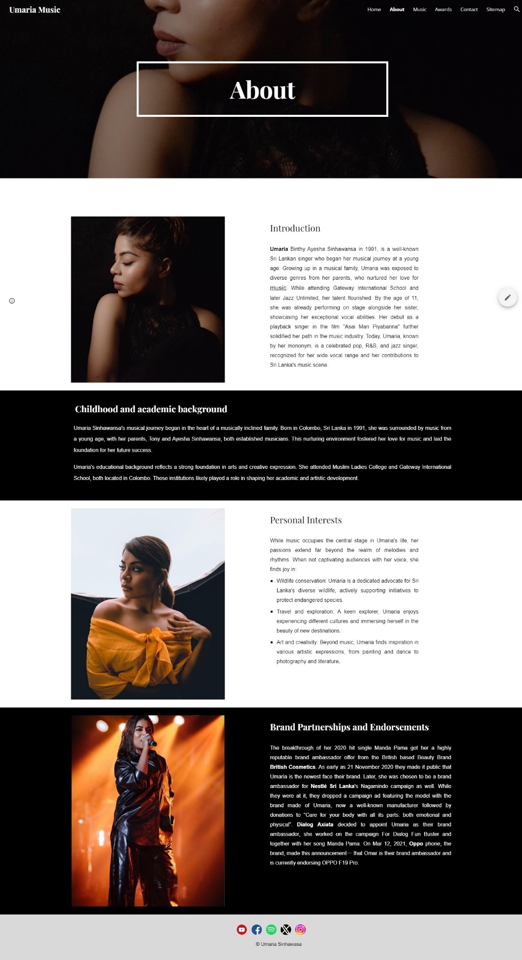

Figure 31: Before optimization: about page

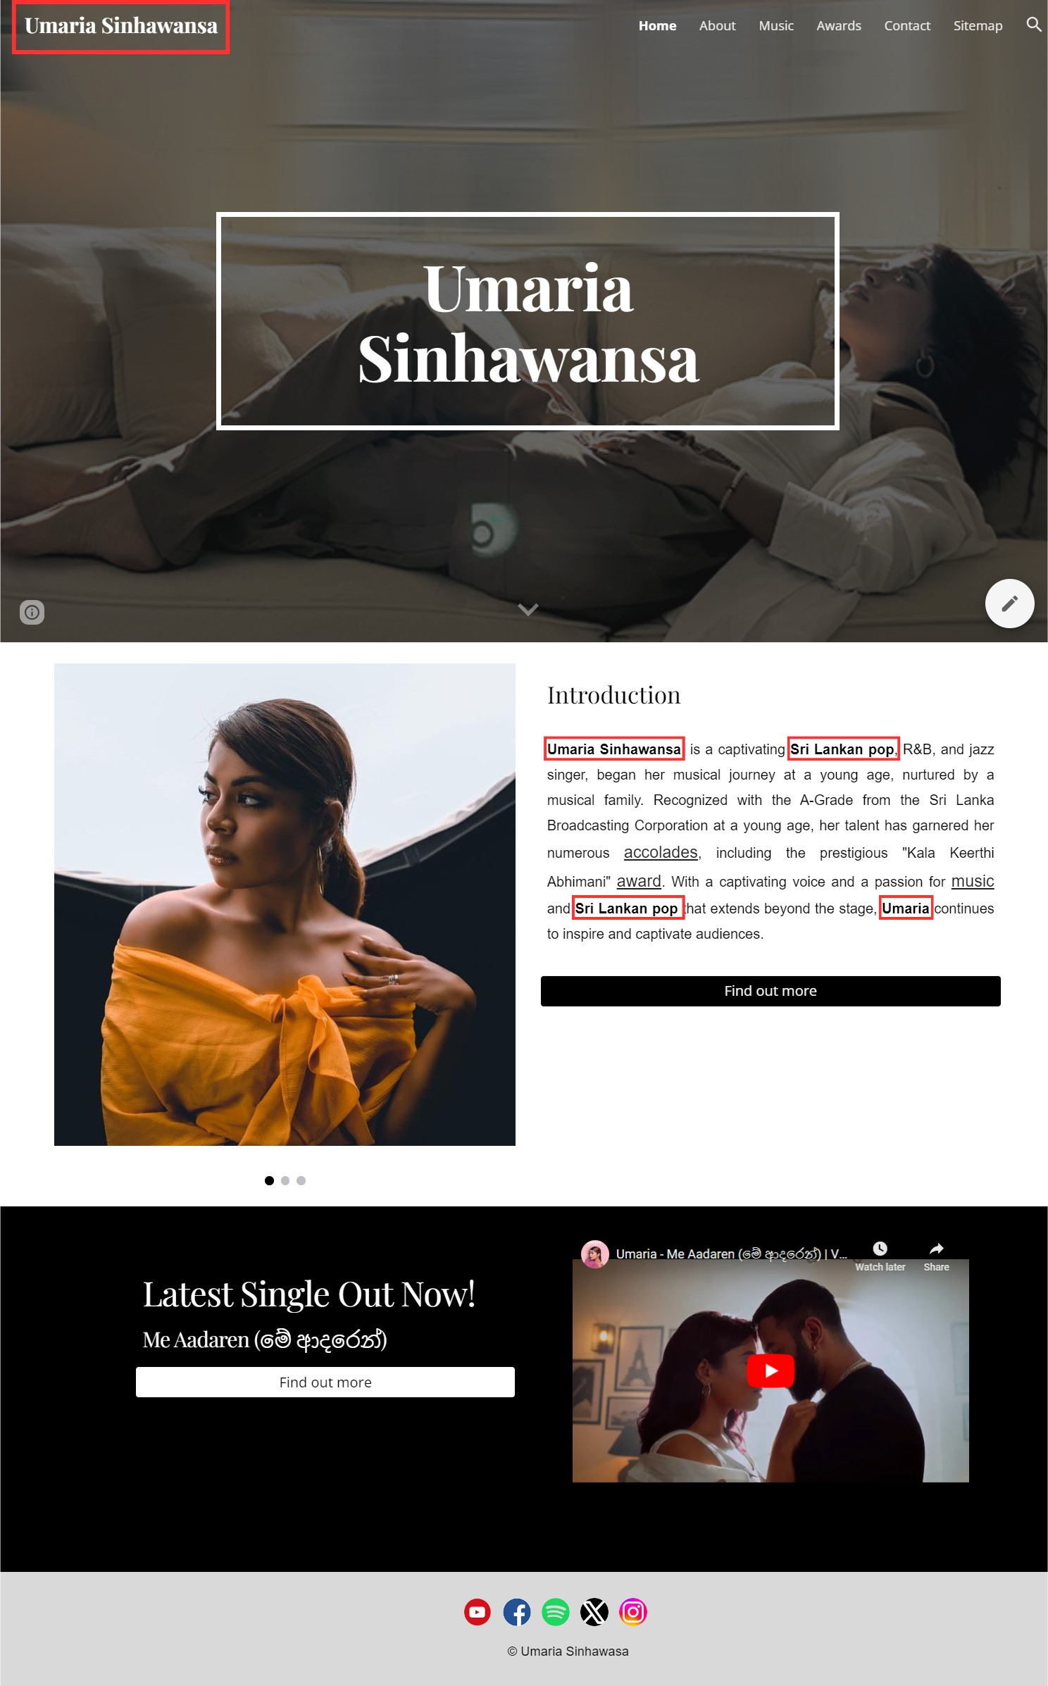

Figure 32: After optimization: homepage

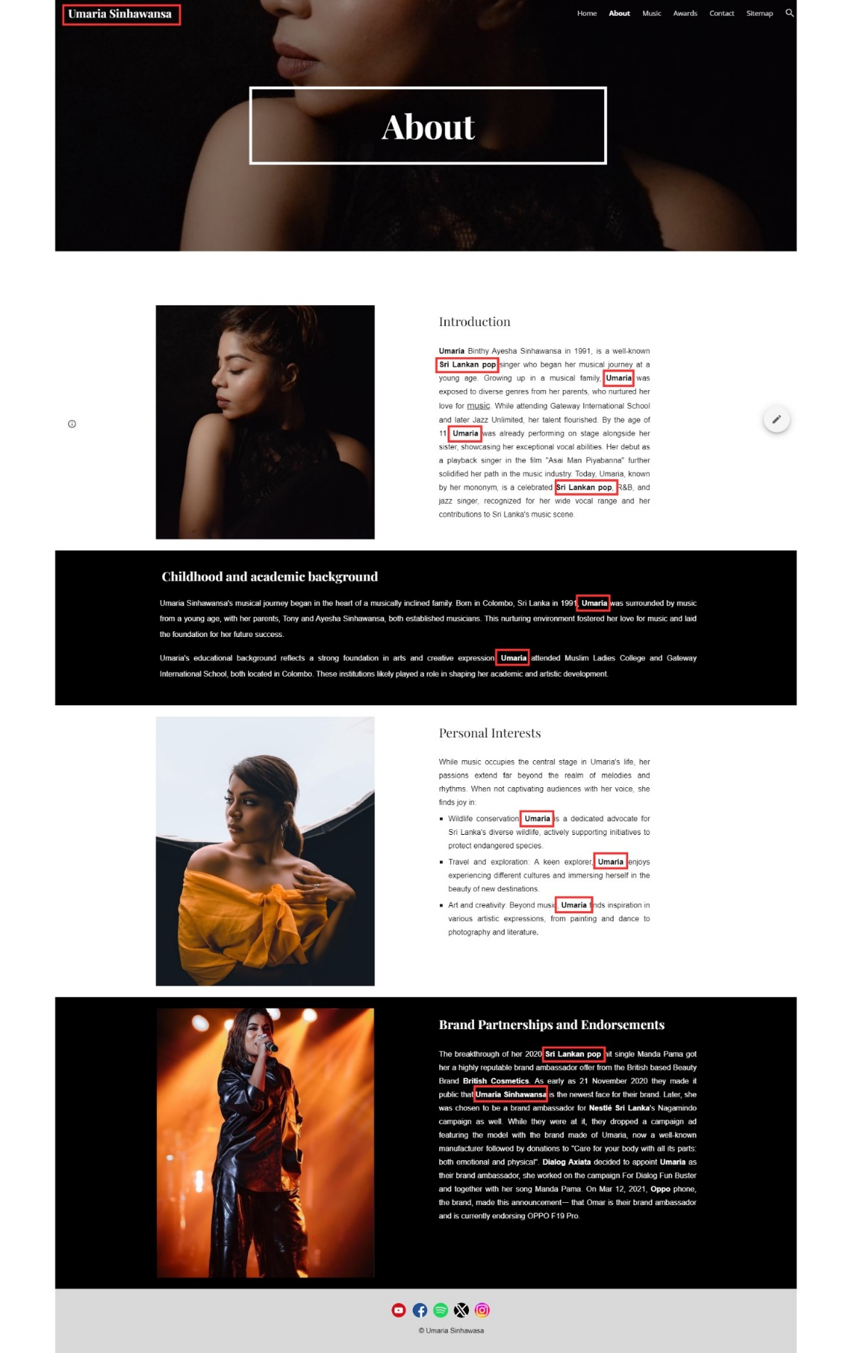

Figure 33: After optimization: about page

## 2.6 Backlinks and Internal Linking

2.6.1 How it Works and Intuition

**Backlinks**Backlinks are an off-site SEO technique, and they are links that redirect to your site (Kelly, 2023). This way it can be considered as a **vote** from other websites so higher the ‘votes’ you have the higher the credibility for your website and it will rank higher on top of search results. (Dean, 2019). This is because if there are **multiple links** that point to your site and another **established** (authoritative, trustworthy and relevant) website is linking to your website, they trust your website enough to refer you and direct traffic which will in turn improve search engine ranking (Vassiliki, no date).

**Internal Linking**

Internal Linking is an on-site SEO technique which involves linking pages inside the site or domain (Brian, 2019). They help search engines find and index your content on the website using bots or crawlers. The more ways there are to reach your content, easier it is to index them (Toonen, 2023). It is recommended that any page on your site should be reachable within 3 clicks or less. This in turn helps the web crawlers identify the important pages on your website and leverage your PageRank (Bhan, 2023).

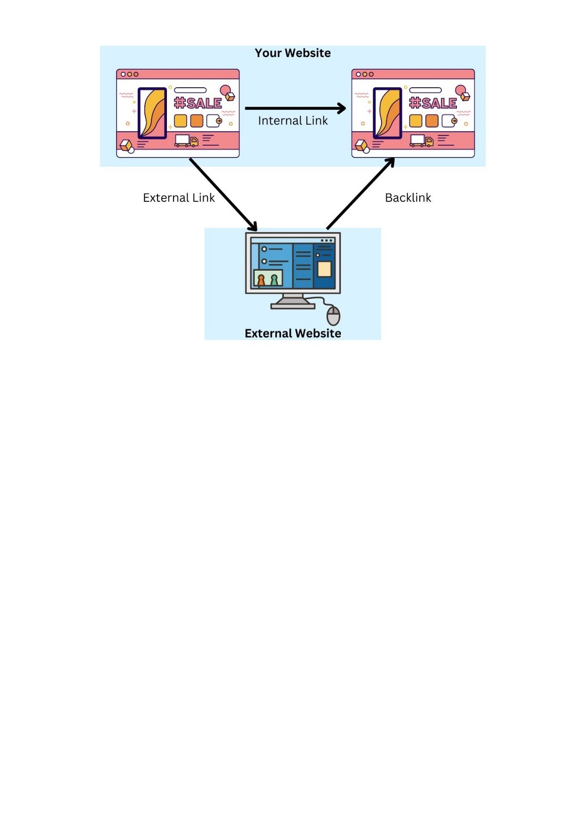

Figure 34: Summary: linking (self-composed)

2.6.2 How it Was Applied

Backlinks have been implemented to this microsite using other musician collaborators such as Bathiya Jayakody, Santhush Weeraman, Sahan Ranwala and Umara Sinahawansa as shown below where they have included a link to this microsite in the context of collaborations and music.

Internal links have been implemented in the home page and about page for words such as music and awards which redirect to Music page and Awards page. Buttons were also used as shown below to redirect to Contact and About pages.

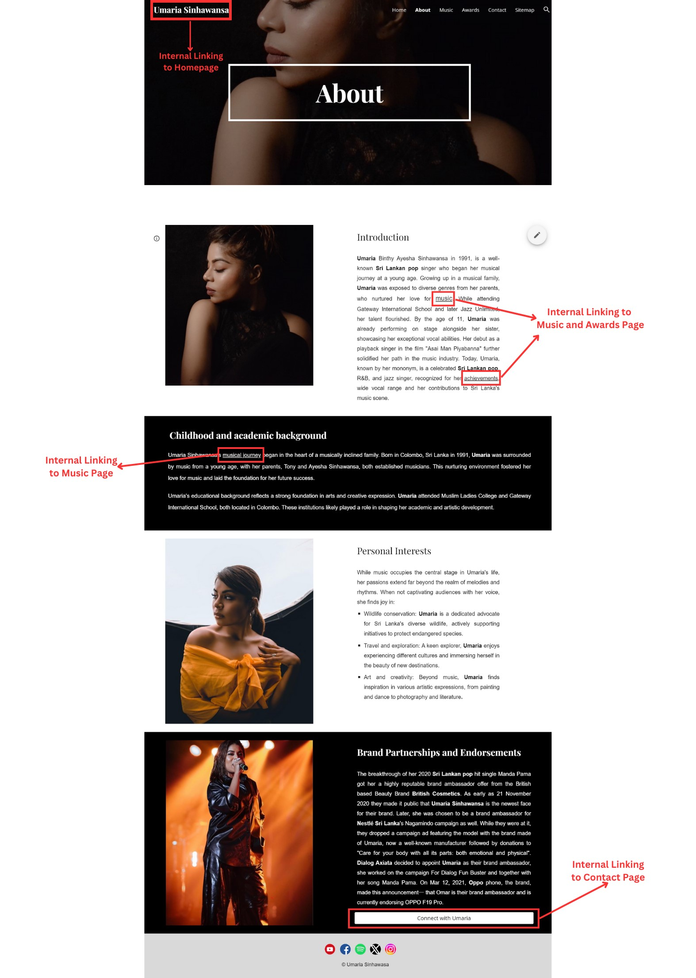

Figure 35: Internal Linking: About page

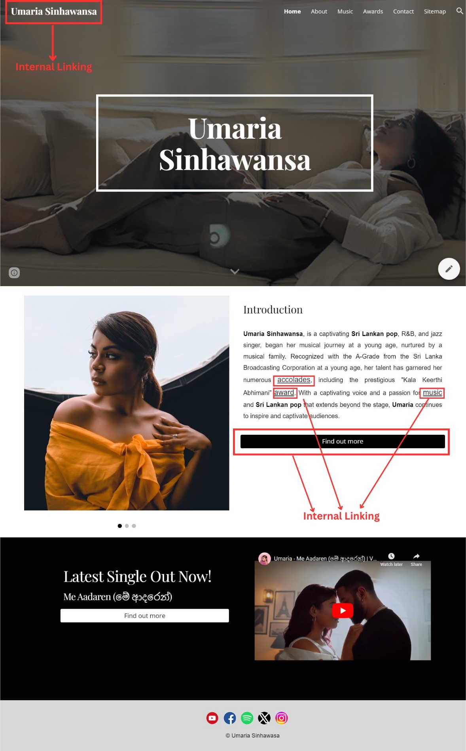

Figure 36: Internal Linking: Home

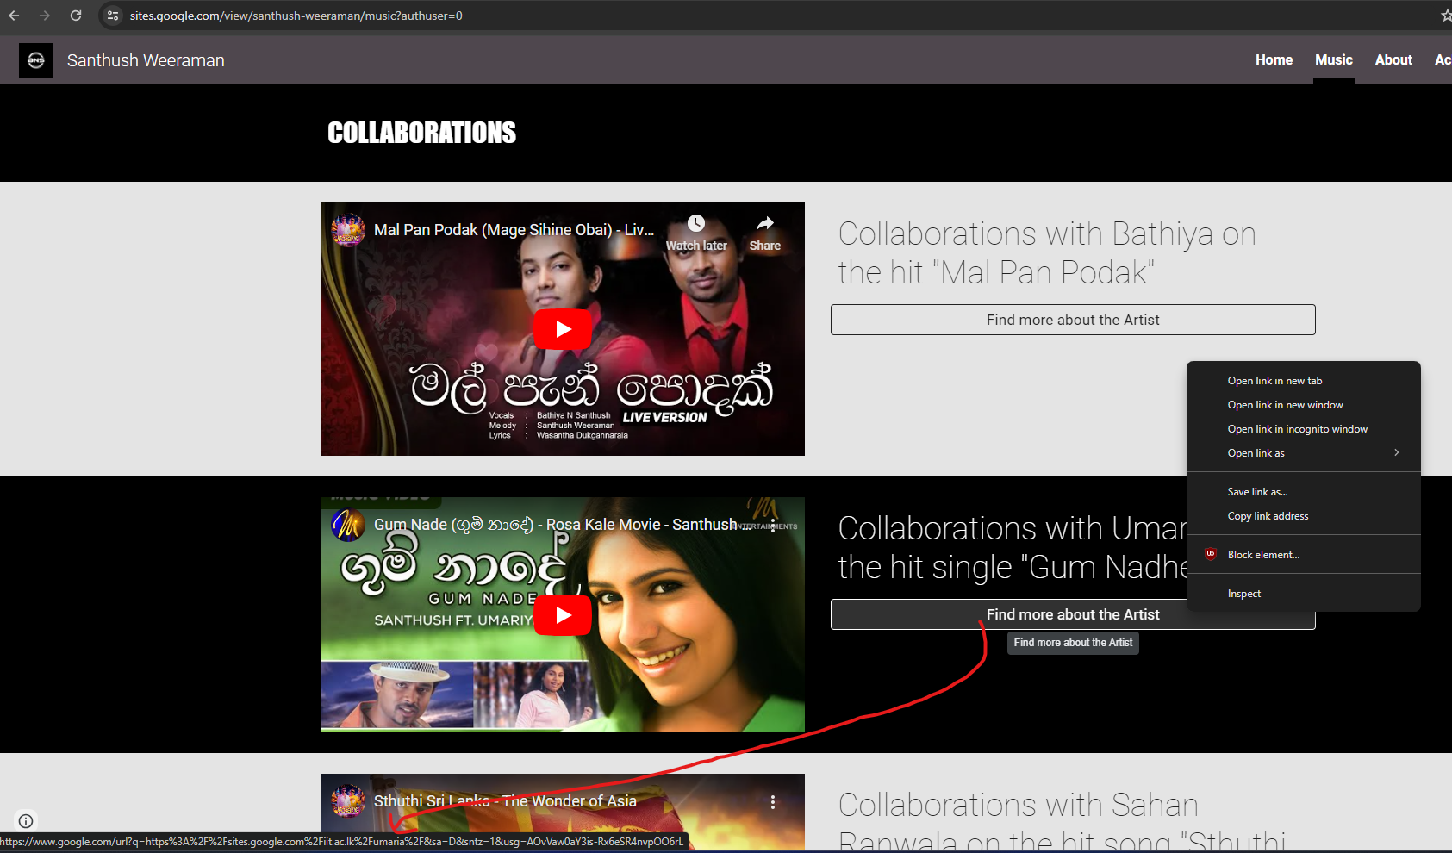

Figure 37: Backlink from Santhush Weeraman

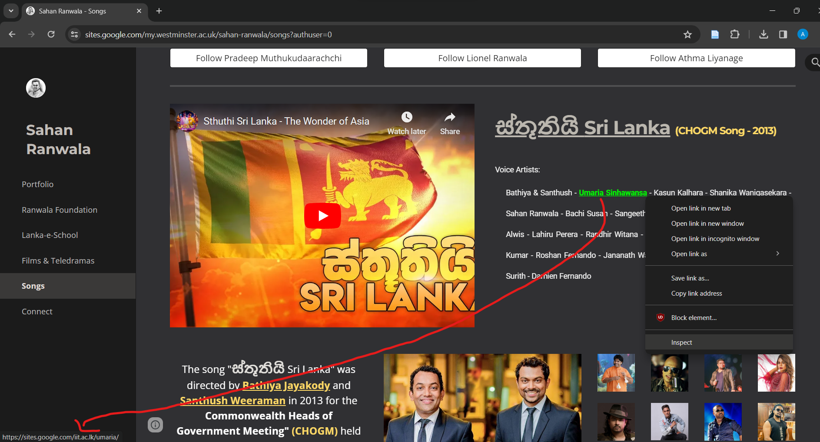

Figure 38: Backlink from Sahan Ranwala

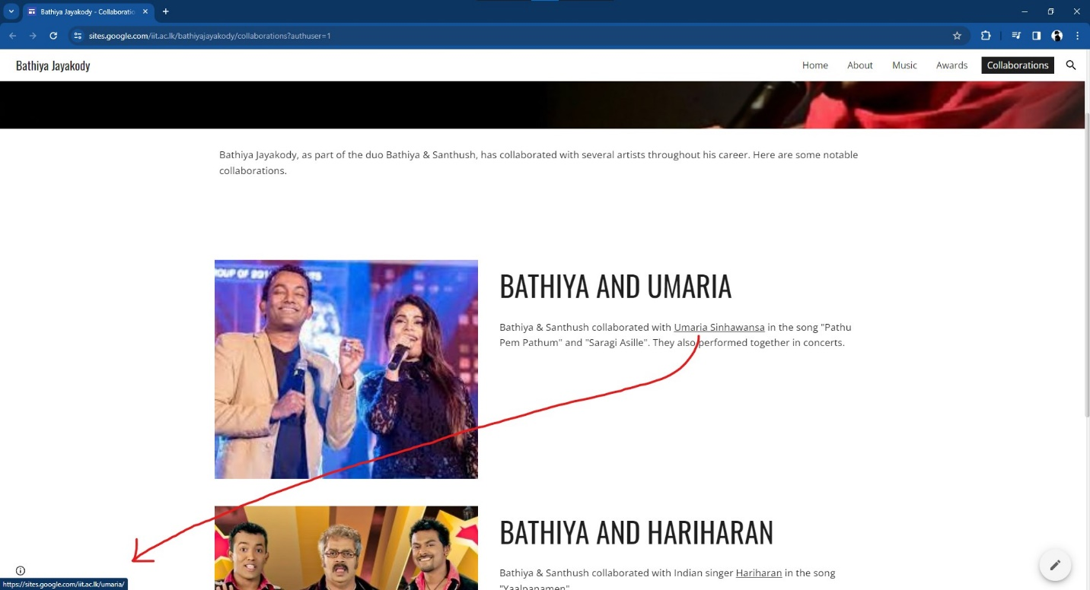

Figure 39: Backlink from Bathiya Jayakody

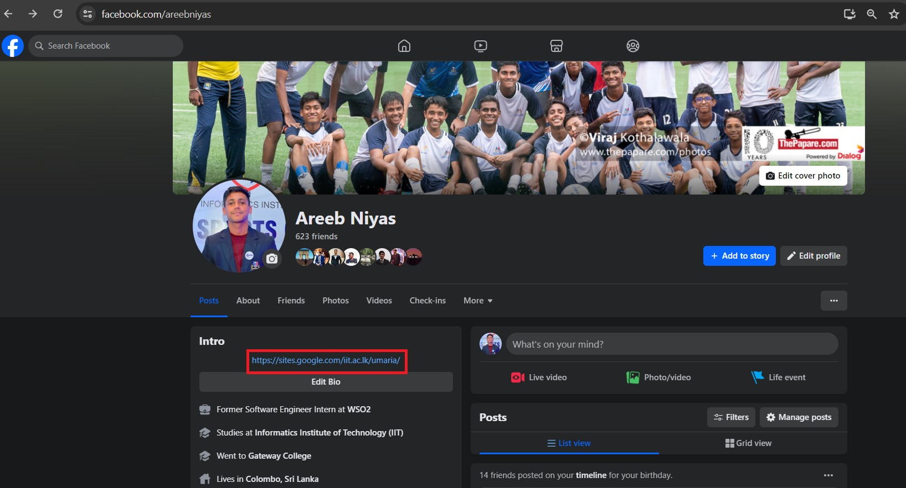

Figure 40: Backlink from Facebook

## 2.7 PageRank Algorithm

### 2.7.1 Diagram

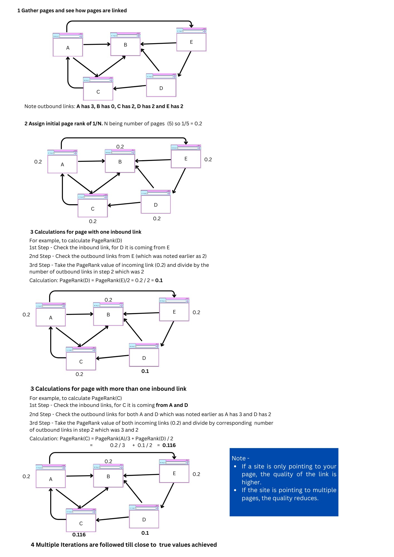

Figure 41: Annotated PageRank algorithm diagram

### 2.7.2 Rationale and Intuition of PageRank Algorithm

PageRank algorithm revolves around the intuition that more the **number of quality inbound links** to your website, higher the credibility of your website (Amine, 2020). Each link is considered as a vote to a page which builds trust. However, all links are not considered as a vote each and the **authority** of a page is taken into consideration (Varangouli, 2023).

Basically, if a page has multiple links then the power of the link is reduced and if a site is only pointing to your page the quality of your link is higher.

It works by each page given a uniform PageRank score then the PageRank is divided by the quality of the inbound link. Then it is distributed to all the other pages iteratively till it reaches a close to true value for its final PageRank (Jones, 2023)

PageRank combines the collective judgement of web authors and authority expressed through links to identify the importance of web pages which is a top-tier search technology mechanism (Hossain, 2023)

### 2.7.3 PageRank Algorithm Manipulation and Potential Countermeasures

**Manipulation**

During the early stages in 2003, the PageRank was available to the public and it ranked pages according to keyword density and links. This lead to manipulation as keyword stuffing was used and money was used to spam backlinks and links were placed in irrelevant places and in large volumes (Varangouli, 2023) because sites wanted to rank higher.

Some other manipulation involved spamming comments with links to a webpage on blogs and forums to increase the number of links. Also, some website owners would pay high authority websites to promote their page using money (PageRank Manipulation and How Google Fight it, 2022)

**Countermeasures**

Cornell Univseirty published a counter by increasing rankings of pages on top level domains and compare linking and linked pages. If it differs massively then it could be considered manipulated (Manipulating PageRank — Adversarial IR and the rise of the Google-bomb, 2017).

From 2020, Google has used **AI** to detect spam from websites. Spam-fighting AI scans the website and filters out spam before displaying to the user which has reduced spam, AI-generated content by more than 80% (PageRank Manipulation and How Google Fight it, 2022)

From 2022, Google updated to counter unnatural links. By using an **AI** model to flag sites that buy links and identify link farms that contains a lot of unverified links (Go, 2024).

# QUESTION 3: Social Media and Traditional Marketing Methods

## 3.1 Social Signals Definition

Social signals are basically metrics used to measure engagement and human interactions on social media platforms like: comments shares, retweets, reposts, subscribes and votes (Author, 2022).

Some examples:

1. The likes, comments and shares on a post or tweet. Shown below is a general relationship between social signals and the reach of a post.  
   The first picture below proves that higher the social signals or interactions with a particular post, higher the reach whereas the second picture below shows that lesser the social signals lower the reach (Gualtieri, 2023).  
     
   

Figure 42: High reach: Instagram post analytics

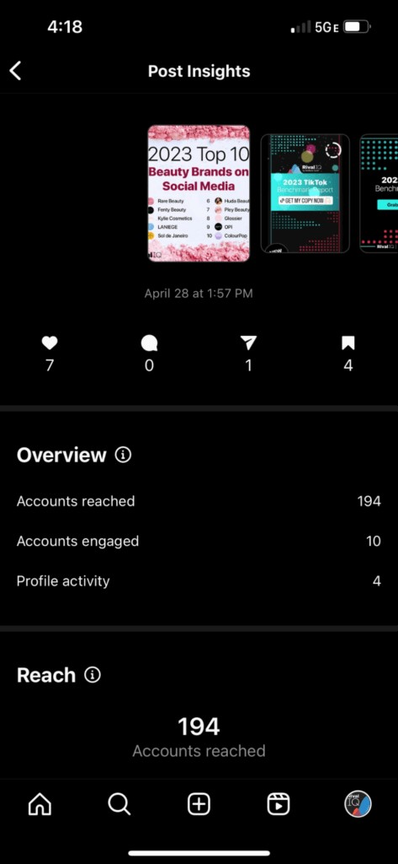

Figure 43: Low reach: Instagram post analytics

1. Replying to stories on Facebook and Instagram.
2. Retweets and reposts on Twitter and LinkedIn

However, it is difficult to measure a good engagement rate because it could be affected by various factors and even paid advertising as well, so they need to be considered. Generally, the likes, comments, shares and reposts are taken and divided by the total number of followers (Gualtieri, 2023).

Some ways in which social signals are improved with examples from Dialog Sri Lanka include:

1. Quality content. Below shows a way in which dialog efficiently communicates an offer using quality content which led to high interactions.  
     
   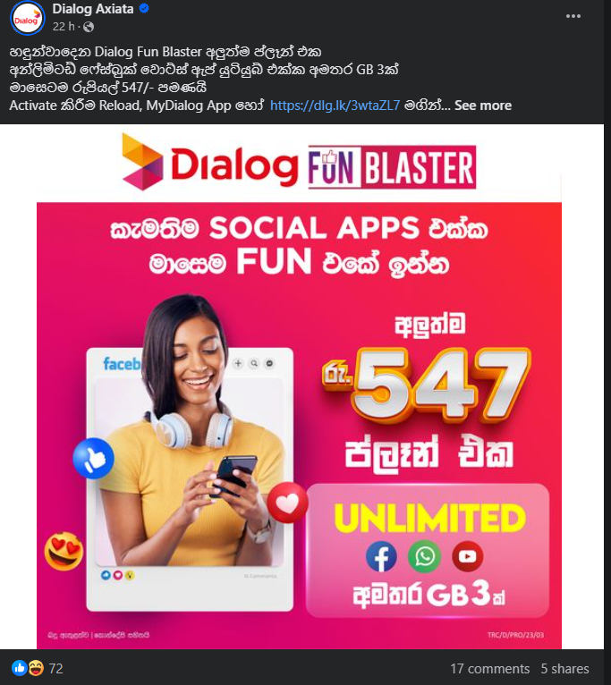

Figure 44: Quality content: Dialog

1. Interactive content such as polls, trivia and clickable content  
     
   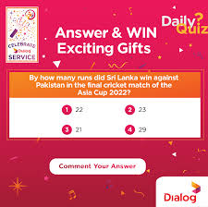

Figure 45: Trivia question by Dialog

1. Being actively responsive  
     
   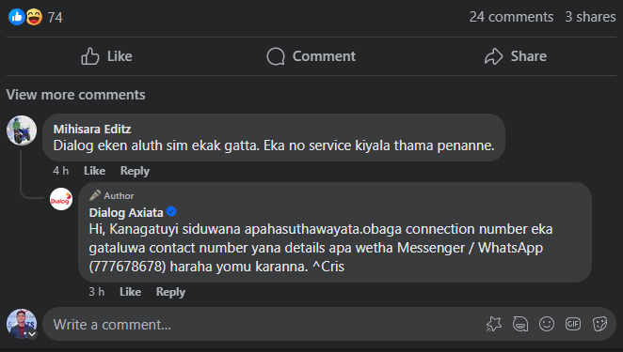

Figure 46: Active responses from Dialog

Therefore, strategies and persistence to improve social signals will allow you to see measurable results (Bhan, 2022).

## 3.2 Social Signals and Search Engine Algorithms

Google released a statement in 2015 that social signals do not affect ranking factor. Social signals rather benefit SEO indirectly (Semrush Team, 2023).

By creating high quality content, increasing engagement. optimizing profiles, businesses can utilize the powerful impact of social media to improve their online presence and SEO performance. However, it may not directly affect search engine algorithms and their rankings (Andrieieva, 2023).

Therefore, social media signals can only indirectly improve search rankings by increasing visibility and getting traffic into the website. For example, if the content is of high quality and engaging this can increase backlinks and improve brand image which may lead to more traffic and improve the rank (Social Media Signals: Do They Boost SEO?, 2024).

### 3.2.1 Advantages

1. Visibility and Traffic  
   When individuals interact, it expands the reach to their followers and communities. This in turn may lead to more visibility and drive traffic (Semrush Team, 2023).
2. Authority  
   More quality and high social signals is an indicator that your page is relevant and reliable as it is engaged by a lot of individuals. So can be considered credible (Pecánek, 2023)

### 3.2.2 Limitations

1. High competition and distraction.  
   Making your conrtent stand out and noticed compared to competitor content may by a tricky challenge (EIH Digital Agency, 2023)
2. Time consuming and resources  
   Maintaining an active page with high responsiveness requires a lot of effort and resources which can be a challenge (EIH Digital Agency, 2023).

## 3.3 Recent Trends in Search Engine Market and Consumer Search

More AI is being used to make search results precise. It can also target specific individuals and topics. AI is also being used to adjust descriptions ad headlines of ads (Settler, 2022).

The rise of visual search which helps individuals find what they want to see using real world images is also a rapidly increasing trend. Many people now are getting accustomed to using images to generate search results (Gilbert, 2022).

Moreover, consumers that use the microphone to utilize voice search are increasing rapidly. Therefore, now SEMs may have to adapt more to voice searches as well (Semrush Team, 2023).

Consumers now also like using images in order to search instead of the traditional typing to generate search. Therefore, the consumer search behavior is constantly revolutionizing and adapting with the recent advancements in accurate generative AI (Third of consumers have used visual search, 2019)

## 3.4 Social Media Marketing and Long-term Relationships

### 3.4.1 Consumer and Producer

**Consumer** is the ultimate end user who uses a product or a service. A customer may purchase a product or service but may not end up using them so they are different from consumer (What is a Consumer | Square Business Glossary, no date). **Producers** manufacture or issue a particular good or service and they can be large companies or even individuals (Producers, 2018).

### 3.4.2 Long-term Consumer-Producer Relationship

Long-term consumer-producer relationships are vital to the growth and success of a business. They help spread the word of mouth, keep your loyal customers, reduce marketing costs and increase consumer lifetime value (Jackson, 2023).

By forming a strong consumer-producer relationship, consumers feel important and loyal to a business. Some ways in which such relationships are built are using: personalized experiences and communication, loyalty programs, collecting feedback and eagerly addressing problems (Rai, 2024).

Positive long-term relationships tend to be mutually beneficial due to the establishment of a stable environment of trust between the consumer and the producer which results in convenience from both parties (Clint, 2022).

### 3.3.3 Methods to Strengthen Long-term Consumer-Producer Relationships

Highlight ways in which this relationship can be strengthened using social media marketing (4 marks).

Social media is a key aspect in strengthening long-term consumer-producer relationships. Some ways in which you can use social media for this purpose include:

* Authenticity  
  Building a social media presence by having genuine content and caring about feedback while being transparent portrays a strong bond. This helps cultivate strong relationships in turn (Shultz, 2014).
* Engagement  
  Companies who have highly responsive social teams tend to build extremely satisfied individuals which in turn helps in the long-term consumer-producer relationship. This is because the consumer feels heard and important (Shirey, no date).
* Personalized Customer Experiences

By providing a personalized experience such as including their first name while addressing online to having live chat bots and cookies to identify similar buying habits help build that personal connection which is key (West, 2023).

* Regular and Updated Content

Connecting regularly and updating the content shows that the business is constantly changing. Promoting using partnerships and collaborations also helps consumers to connect and relate to people they look upto and validate their thoughts (Hayes, 2021).

### 3.3.4 Real-world Example

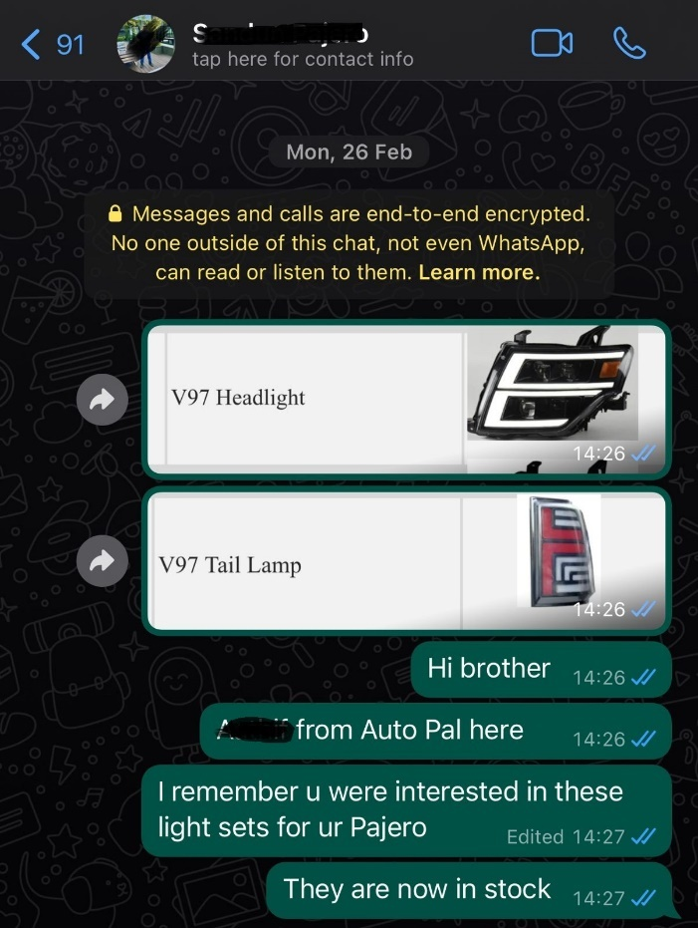

Figure 47: Personalized messaging: Auto Pal

Above screenshot illustrates that by remembering the needs and sending personalized messages, would make a previous customer of AutoPal (case study covered in Q1) feel heard and important in turn strengthening long-term consumer-producer relationship.

# References

Amine, A. (2020). PageRank algorithm, fully explained. *Medium*. Available from https://towardsdatascience.com/pagerank-algorithm-fully-explained-dc794184b4af [Accessed 14 March 2024].

Andrieieva, D. (2023). Social Signals And Their Influence On Rankings | seobase. Available from https://seobase.com/do-social-signals-directly-influence-rankings [Accessed 15 March 2024].

Author, C. (2022). Social Signals and SEO: What You Need to Know (and 7 Steps to Take). *Social Media & Influencer Marketing Speaker, Consultant & Author*. Available from https://nealschaffer.com/social-signals-seo/ [Accessed 15 March 2024].

Bhan, M. (2022). 10 Ways to Improve Your Social Signals for SEO. *WordStream*. Available from https://www.wordstream.com/blog/ws/2022/10/20/social-signals-for-seo [Accessed 15 March 2024].

Bhan, M. (2023). Internal Linking: Types, Tips & Tactics to Improve Your SEO. *WordStream*. Available from https://www.wordstream.com/blog/ws/2022/05/04/internal-linking [Accessed 14 March 2024].

Brian, D. (2019). Internal Linking for SEO: The Complete Guide. *Backlinko*. Available from https://backlinko.com/hub/seo/internal-links [Accessed 14 March 2024].

Bruin, L. de. (2017). Marketing Funnel EXPLAINED with EXAMPLES | B2U | Business-to-you. *B2U - Business-to-you.com*. Available from https://www.business-to-you.com/marketing-funnel/ [Accessed 28 February 2024].

Chappal, M.S. (2023). What’s a Good Funnel Conversion Rate? (& Tips for Calculating & Improving Yours) | Databox Blog. *Databox*. Available from https://databox.com/improve-your-funnel-conversion-rate [Accessed 28 February 2024].

Clint, F. (2022). What is Customer Relations? Everything You Need to Know. Available from https://blog.hubspot.com/service/customer-relations [Accessed 15 March 2024].

Dean, B. (2019). What Are Backlinks in SEO? & Why You Need Them. *Backlinko*. Available from https://backlinko.com/hub/seo/backlinks [Accessed 14 March 2024].

Decker, A. (2022). The Ultimate Guide to Customer Acquisition for 2023. Available from https://blog.hubspot.com/service/customer-acquisition [Accessed 28 February 2024].

Digital Marketing Funnel Stages. (2023). *Pathlabs*. Available from https://www.pathlabs.com/blog/digital-marketing-funnel-stages [Accessed 28 February 2024].

EIH Digital Agency. (2023). What are a few advantages and disadvantages of social media in SEO? *Quora*. Available from https://www.quora.com/What-are-a-few-advantages-and-disadvantages-of-social-media-in-SEO [Accessed 15 March 2024].

Gilbert, N. (2022). 8 Latest Search Marketing Trends for 2024 - A Look Into What’s Next Ahead. *Financesonline.com*. Available from https://financesonline.com/search-marketing-trends/ [Accessed 15 March 2024].

Go, S. (2024). Unnatural Links: What They Are and How to Fix Your Link Profile. *Semrush Blog*. Available from https://www.semrush.com/blog/unnatural-links/ [Accessed 15 March 2024].

Gualtieri, J. (2023). How to Measure and Boost Your Instagram Stories Engagement. *Rival IQ*. Available from https://www.rivaliq.com/blog/instagram-stories-engagement/ [Accessed 15 March 2024].

Hayes, R. (2021). Building Lasting Customer Relationships Through Social Media. *Debutify*. Available from https://debutify.com/blog/10-ways-to-build-lasting-customer-relationships-through-social-media/ [Accessed 15 March 2024].

Hossain, S. (2023). PageRank Algorithm. *Computing for All*. Available from https://computing4all.com/courses/introductory-data-science/lessons/page-rank-algorithm [Accessed 15 March 2024].

Indeed, E.T. (2023). Acquisition Marketing: Everything You Need To Know | Indeed.com. Available from https://www.indeed.com/career-advice/career-development/acquisitions-marketing [Accessed 28 February 2024].

Jackson, E. (2023). Long Term Customer Relationships Examples. *Rexcer Blog*. Available from https://blog.rexcer.com/long-term-customer-relationships-examples/ [Accessed 15 March 2024].

Jones, D. (2023). Google PageRank Explained for SEO Beginners. *Search Engine Journal*. Available from https://www.searchenginejournal.com/google-pagerank/483521/ [Accessed 15 March 2024].

Kelly, L. (2023). What Are Backlinks & Why They Matter in SEO. *Semrush Blog*. Available from https://www.semrush.com/blog/what-are-backlinks/ [Accessed 14 March 2024].

Manipulating PageRank — Adversarial IR and the rise of the Google-bomb. (2017). Available from https://blogs.cornell.edu/info2040/2017/10/17/manipulating-pagerank-adversarial-ir-and-the-rise-of-the-google-bomb/ [Accessed 15 March 2024].

Meissner, M.H. (2020). A User-Centered Approach to Landing Page Optimization in a Software-as-a- Service Business.

PageRank Manipulation and How Google Fight it. (2022). Available from https://blogs.cornell.edu/info2040/2022/10/30/pagerank-manipulation-and-how-google-fight-it/ [Accessed 15 March 2024].

Pecánek, M. (2023). Why Social Signals Matter for SEO (It’s Not a Ranking Factor). *SEO Blog by Ahrefs*. Available from https://ahrefs.com/blog/social-signals/ [Accessed 15 March 2024].

Producers. (2018). *Econlib*. Available from https://www.econlib.org/library/Topics/HighSchool/Producers.html [Accessed 15 March 2024].

Rai, S. (2024). Top 10 Ways to Build Customer Relationships. *Yellow.ai*. Available from https://yellow.ai/blog/build-customer-relationship/ [Accessed 15 March 2024].

Retention Funnel: What, When, How and Why. (2023). *FasterCapital*. Available from https://fastercapital.com/content/Retention-Funnel--What--When--How-and-Why.html [Accessed 28 February 2024].

Semrush Team. (2023). 7 Up-to-Date Voice Search Statistics (+ 3 Best Practices). *Semrush Blog*. Available from https://www.semrush.com/blog/voice-search-statistics/ [Accessed 15 March 2024].

Semrush Team. (2023). Social Signals & SEO: Do Shares + Likes Help You Rank Higher? *Semrush Blog*. Available from https://www.semrush.com/blog/social-signals-seo/ [Accessed 15 March 2024].

Settler, A. (2022). 15 Best Search Engine Marketing Trends in 2023. *The Techno Studio UK*. Available from https://thetechnostudiouk.com/sem-trends/ [Accessed 15 March 2024].

Shepherd, L. (2019). Retention Marketing vs. Customer Acquisition (Should You Shift Focus?) | BigCommerce. *The BigCommerce Blog*. Available from https://www.bigcommerce.com/blog/retention-marketing/ [Accessed 28 February 2024].

Shirey, T. (no date). Why Your Company Should Use Social Media to Build Customer Relationships. *WebFX*. Available from https://www.webfx.com/blog/marketing/why-your-company-should-use-social-media-to-build-customer-relationships/ [Accessed 15 March 2024].

Shultz, M. (2014). Why is social media a beneficial relationship building tool? *MSU Extension*. Available from https://www.canr.msu.edu/news/why_is_social_media_a_beneficial_relationship_building_tool [Accessed 15 March 2024].

Silva, C. (2023). Keyword Search Volume: A Beginner’s Guide. *Semrush Blog*. Available from https://www.semrush.com/blog/keyword-search-volume/ [Accessed 13 March 2024].

Social Media Signals: Do They Boost SEO? (2024). *AIContentfy*. Available from https://aicontentfy.com/en/blog/social-media-signals-do-they-boost-seo [Accessed 15 March 2024].

Spilka, D. (2023). How to build a lead generation funnel | Zapier. Available from https://zapier.com/blog/lead-generation-funnel/ [Accessed 28 February 2024].

The Ultimate Guide to Keyword Competition. (2023). *WordStream*. Available from https://www.wordstream.com/articles/ultimate-guide-to-keyword-competition [Accessed 13 March 2024].

Third of consumers have used visual search. (2019). *Smart Insights*. Available from https://www.smartinsights.com/ecommerce/third-consumers-use-visual-search/ [Accessed 15 March 2024].

Toonen, E. (2023). Internal linking for SEO: Why and how? *Yoast*. Available from https://yoast.com/internal-linking-for-seo-why-and-how/ [Accessed 14 March 2024].

Varangouli, E. (2023). Everything You Need to Know About Google PageRank. *Semrush Blog*. Available from https://www.semrush.com/blog/pagerank/ [Accessed 14 March 2024].

Vassiliki, B. (no date). SEARCH ENGINE OPTIMIZATION TECHNIQUES.

West, C. (2023). How to build customer relationships with social media. *Sprout Social*. Available from https://sproutsocial.com/insights/build-customer-relationships/ [Accessed 15 March 2024].

What is a Consumer | Square Business Glossary. (no date). *Square*. Available from https://squareup.com/gb/en/glossary/consumer?optimizely-snippet-injection-enabled=true&optly_called=true&optly_vars=edi_1_0_uk_nav:variation_2 [Accessed 15 March 2024].

Wolanin, A. (2023). Hashtag Marketing: 10 Tactics to Boost Business | Brand24. Available from https://brand24.com/blog/hashtag-marketing-tactics-that-will-boost-your-business/ [Accessed 6 March 2024].